**Tutorial link: Basic Uses of Git For Beginners(Tutorial 1)** [**https://www.youtube.com/watch?v=C4lNdjgYoi8&list=PL_XxuZqN0xVDDw5eyzuRDXBzgdnW7UpDF**](https://www.youtube.com/watch?v=C4lNdjgYoi8&list=PL_XxuZqN0xVDDw5eyzuRDXBzgdnW7UpDF)

**Local repository creates:  
*git install:** <https://git-scm.com/> (download from here -> for windows)

*open cmd🡪 git - -version

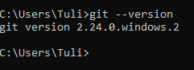  
  
*need to create local repository: repository means folder or directory which able to track my git.  
🡪 Two types of repository (local, online)

*repository creates in local pc:  
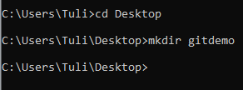

*directory ta k bolte hobe eta amr git directory:

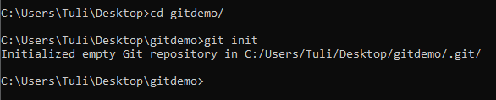

*git file ta normally hide thake..er jonno “hidden item” select kore dbo

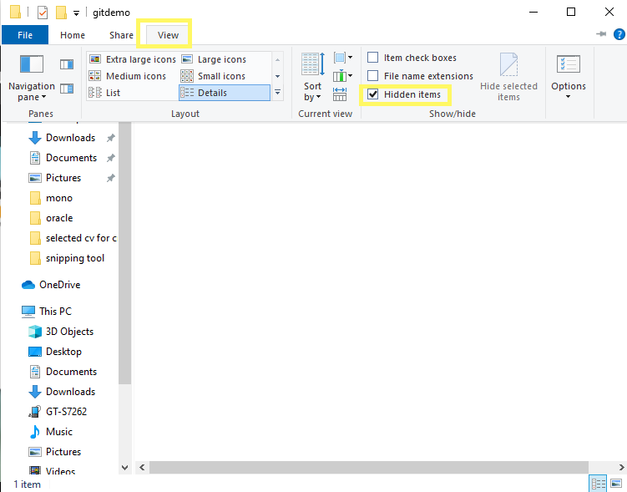

*ai folder e hat deyar dorkar nai

*folder e ekta text create korbo

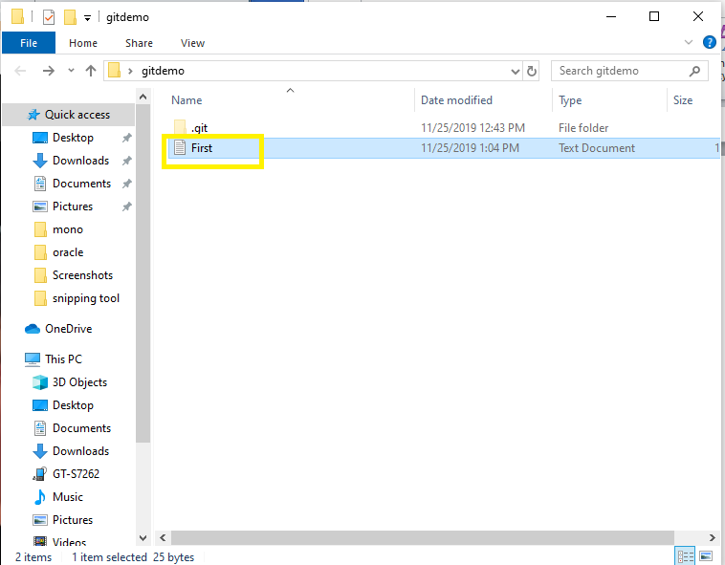

**\*git ta ki obosthay ache:**

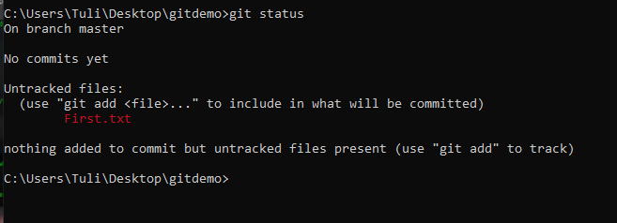

*first.txt file ta ekhono untrack obosthay ache  
*file jevabe track korbo:

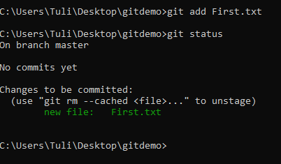

*commit korbo:

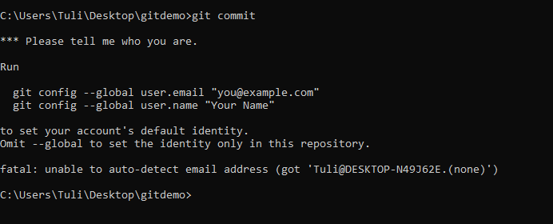

Git config:   
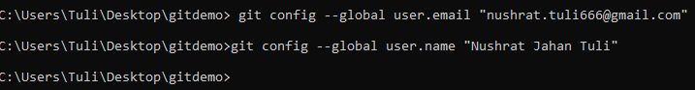  
*now commit part is start:  
🡪 git commit

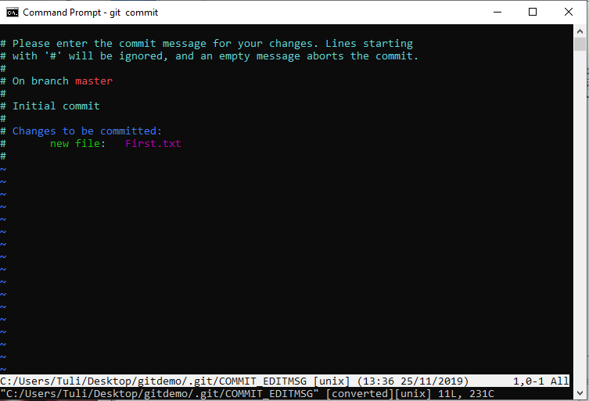

*eta k vim bole

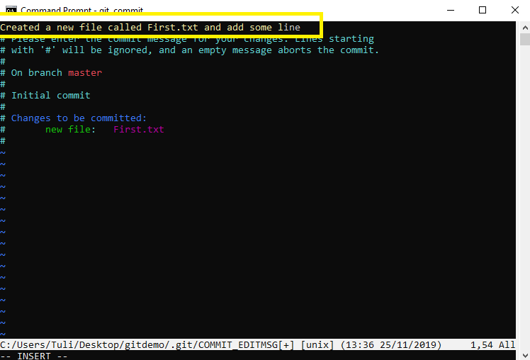  
*press esc, then insert lekha ta chole jabe then write “:x” and press enter

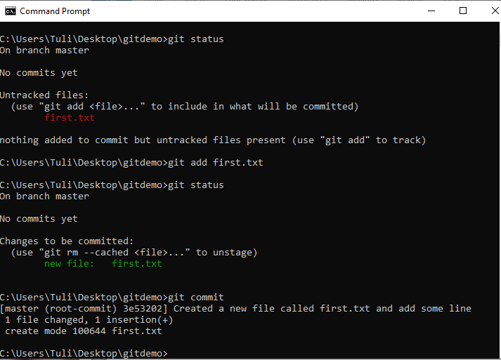

*commit je korechi seta track korte parche kina:

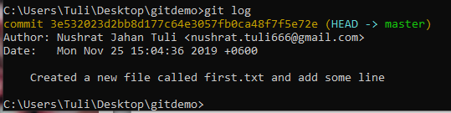  
  
* “git status” likhe dekhbo git er present ki obostha:

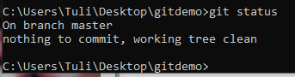

*etar mane hocche sob kichu clean ache, tmi kaj chaliye jete paro

Jodi kono existing file again edit korte chai:  
*again open first.txt file and write some extra line  
*again write “git status” in cmd file

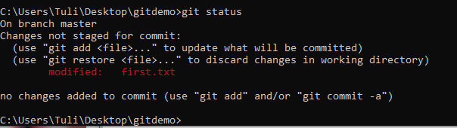

*sob gulo file eksathe add korte chaile “git add .”



*again call “git status”

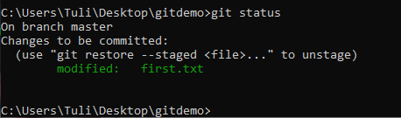

*commit korbo ebar:   
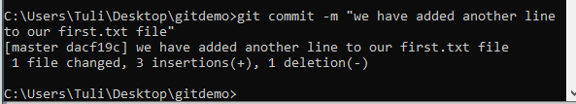  
*again git status jante chachhi:  
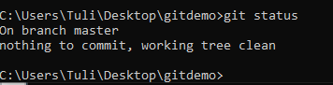  
*git log-> dekhabe koyta commit korechi

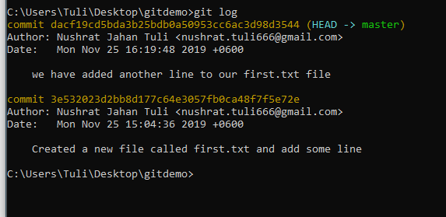

* commit msg gulo Jodi ek line e dekhte chai: git log --one line

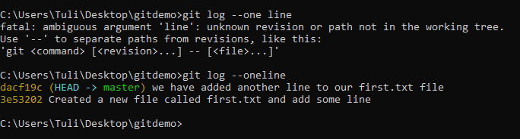

**Tutorial link: Basic Uses of Git For Beginners (Tutorial 2)**

<https://www.youtube.com/watch?v=hTFSeWgT7jg&list=PL_XxuZqN0xVDDw5eyzuRDXBzgdnW7UpDF&index=2>

*cmd🡪cd Desktop/  
 cd gitdemo/

*open gitdemo file and create another text file: “second.txt” and write something

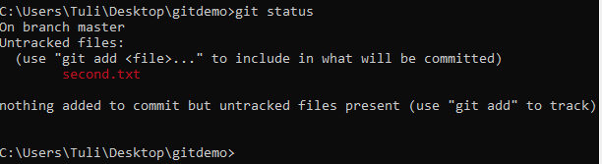

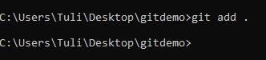  
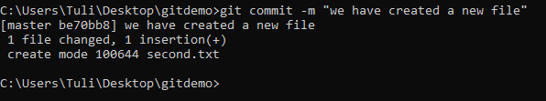  
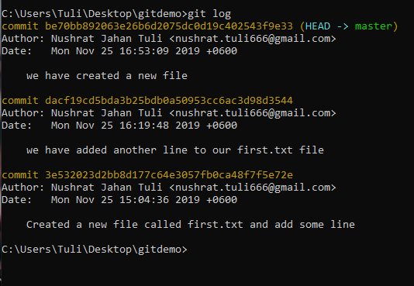

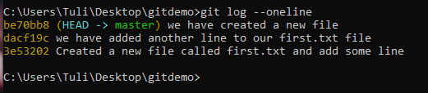

*Jodi **dacf19c** commit e ki hoyechilo jante chai:  
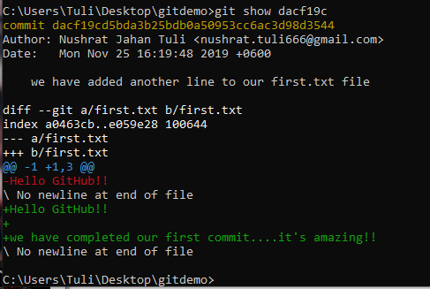  
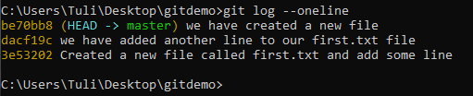  
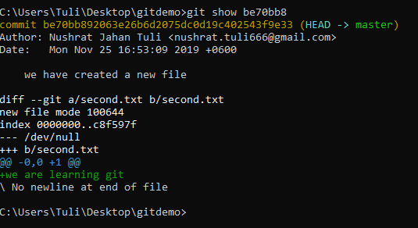

*second text file ta open kore abar ekta line likhbo:  
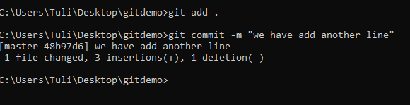

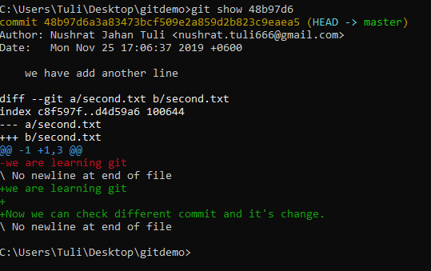

**Diff command**

**\*** open second.txt again and write “Now we are going to learn about diff command”

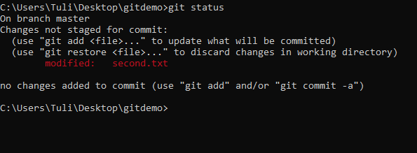  
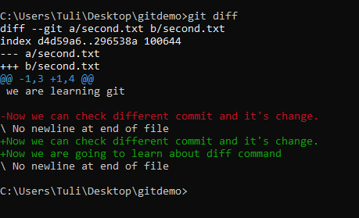  
  
*delete one line from second.txt  
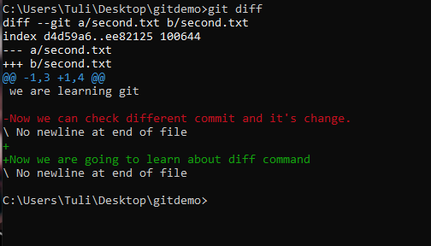  
*majhkahner line ta nai tai minus sign bujhacche ” Now we can check different commit and it's change.”

*staging korbo

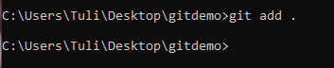

*ekbar stage hoye gele r diff commad kaj korbe na  
*Jodi staging korar por o again diff korte chai:  
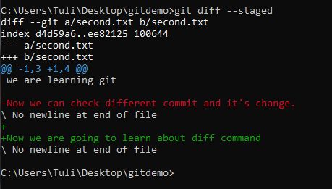  
*staging kora hoye gele Jodi sudhu diff use kore taile kichu dekhabe na  
**git diff –staged** use korte hobe

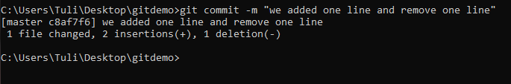  
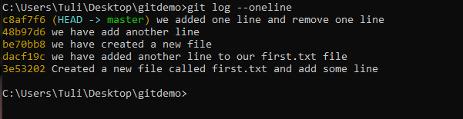  
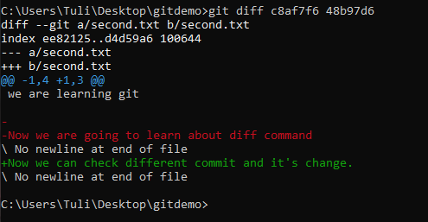

*red lin tai bujhai dlt hoyeche eta r green line tai bujhai ei line ta lekha hoyeche

**Git theke file remove korte chaile:**

**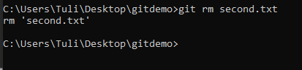  
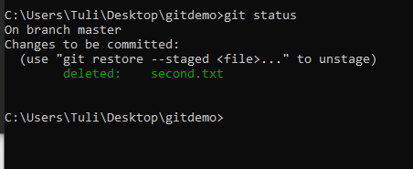**

**\*ebar remove kora file ta k staging area theke ber kore dbo:  
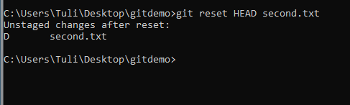  
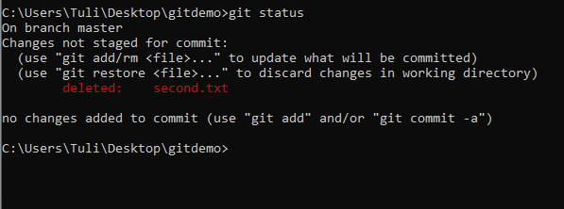  
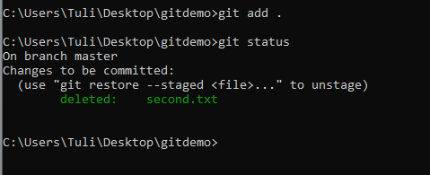  
je file ta k delete korechi seta k commit korbo**

**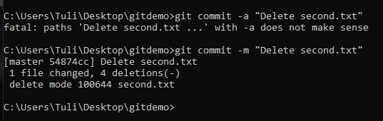  
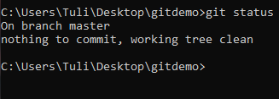**

**\*open first.txt again and write:** we have learned a lot about git  
now we can start using git and git hub

**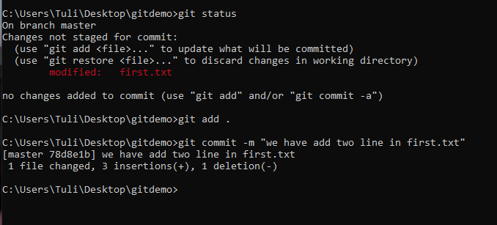  
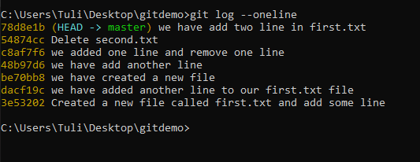**

**\*“3e53202 Created a new file called first.txt and add some line**” sudhu first line ta ami chai, porer line gula rakhte chacchi na

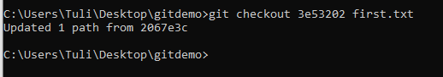

*ebar first.txt file ta open korle dekhte pabo sudhu first line ta ache  
porer duita line delete hoye geche

*but ami Jodi chai abar ager sob koyta line back ante,

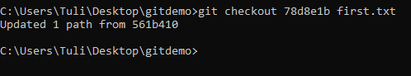  
*ebar dekhbo je abar aager 3ta line chole esheche

**Tutorial link: GitHub introduction For Beginners (Tutorial 3)**

<https://www.youtube.com/watch?v=-IpyFnFkAPc&list=PL_XxuZqN0xVDDw5eyzuRDXBzgdnW7UpDF&index=3>

online account create: github e free private repository kora jabe na, git lab e jabe  
  
git hub account: email: [nushrat.tuli666@gmail.com](mailto:nushrat.tuli666@gmail.com) ; pass: cse05506809

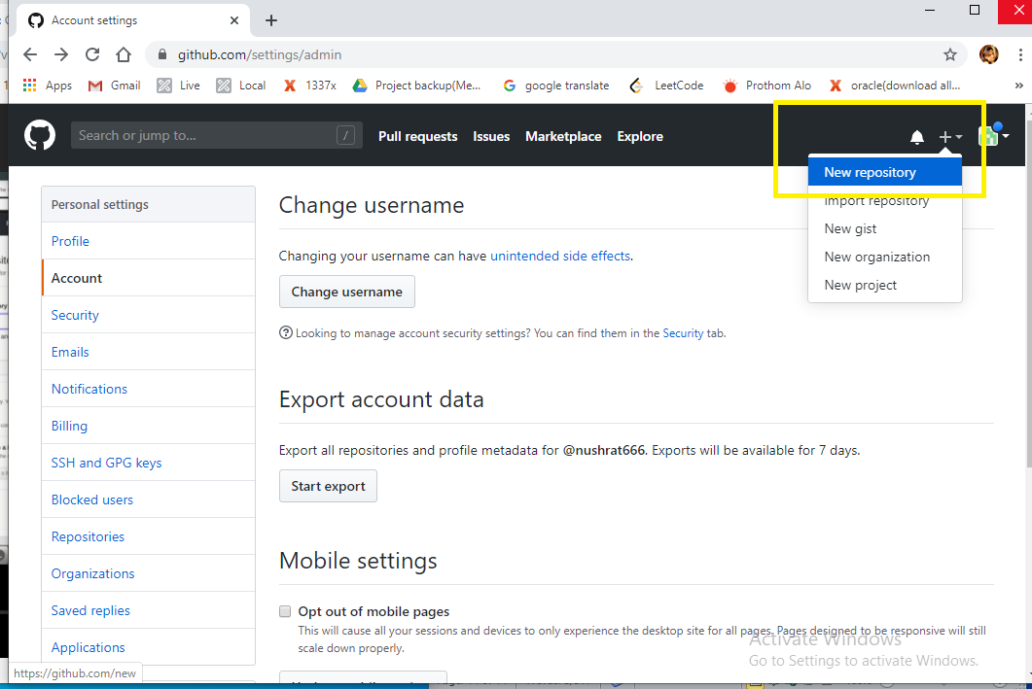

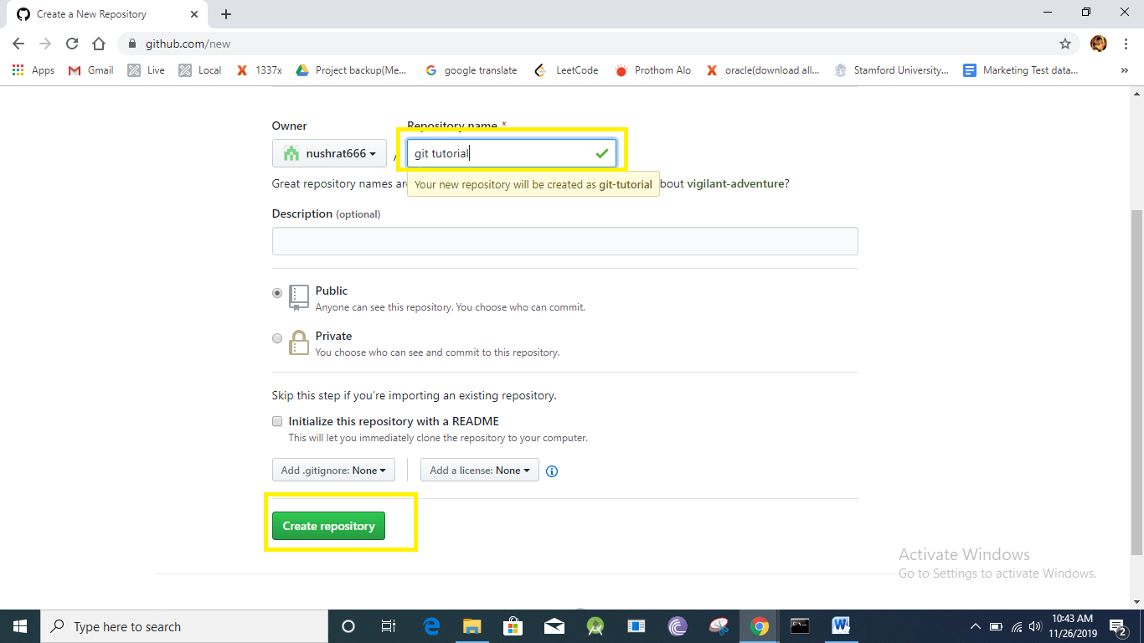

*online e repository thakleo, kaj local ei kora lagbe  
kaj korbo local e, kaj seshe push kore dbo eta online e

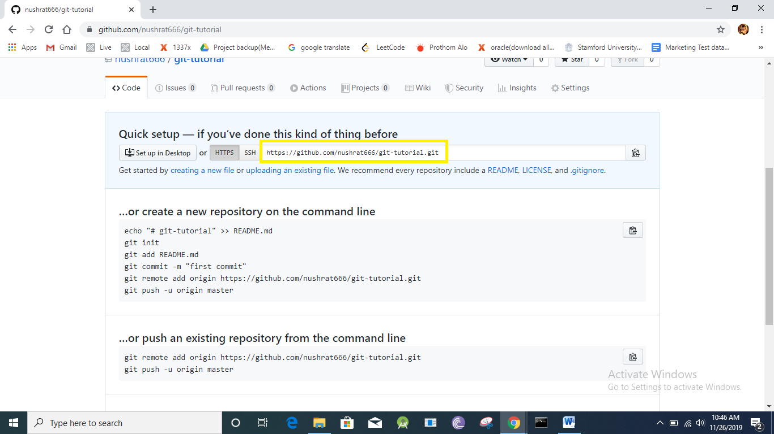

*Copy this link and open terminal



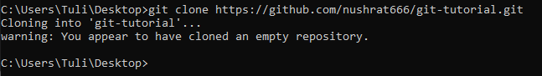

*desktop e git tutorial bole new ekta folder open hobe

*je folder ta crete hoise se nam ta rakhte chai na, tai delete kore dbo

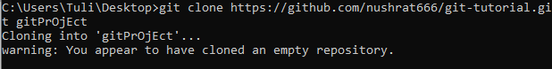

*gitProject name r notun folder open hobe, name change hobe but sob kichu aager motoi thakbe

*notepad e hello.java name r ekta file create korbo got repository tai

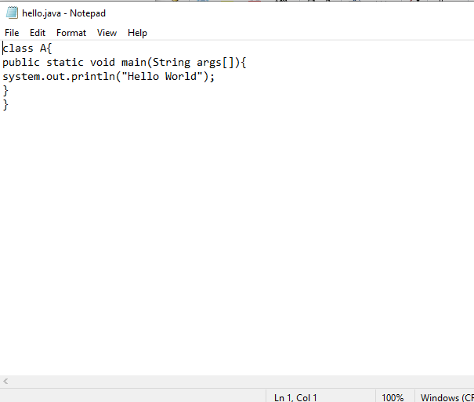



*visual studio code download: <https://code.visualstudio.com/docs/?dv=win>

*visual studio code ta open kore ekhon hello.java file ta open korbo

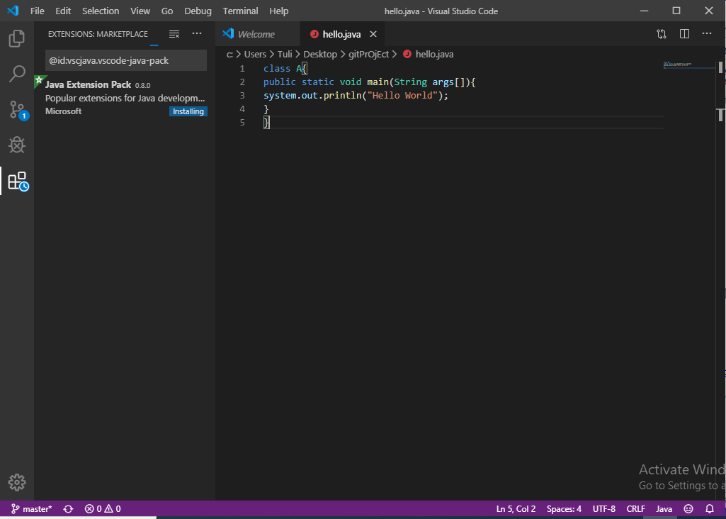

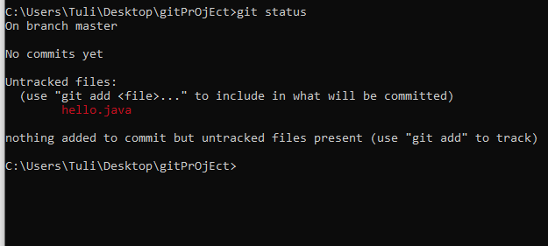

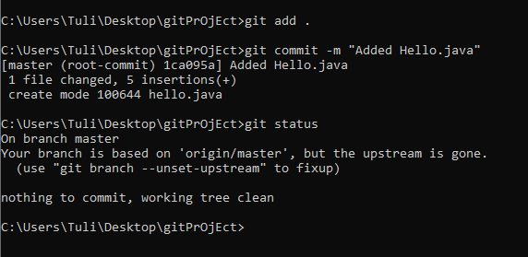

Online e push korbo:

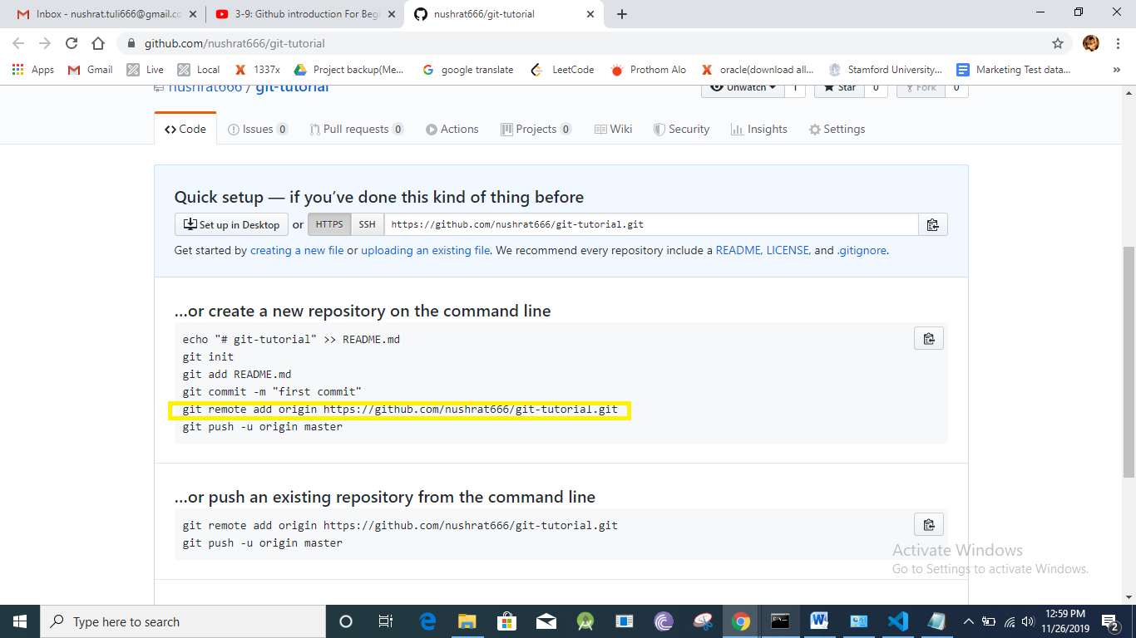

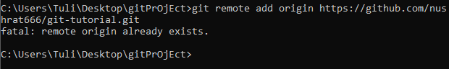



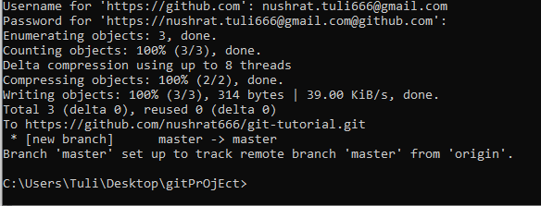

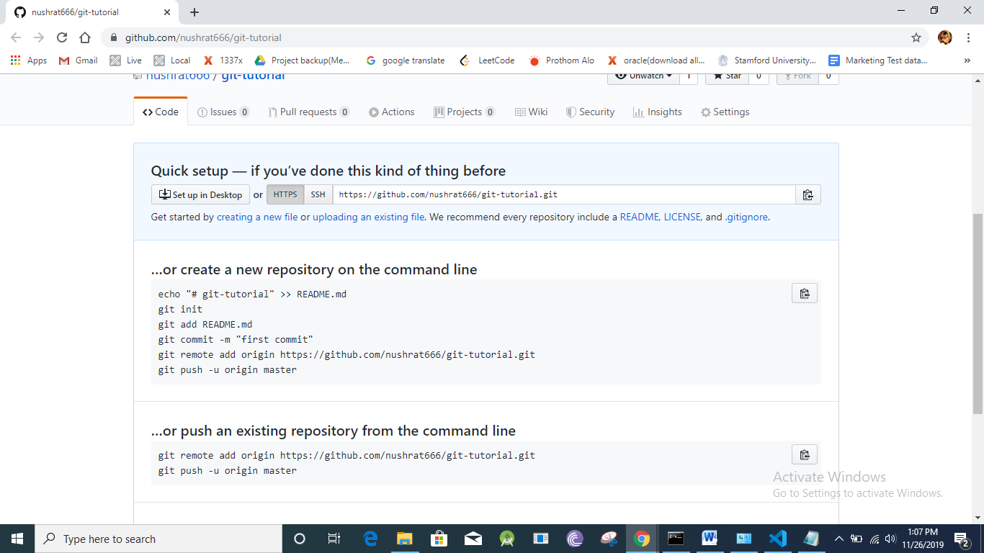  
*refresh this page

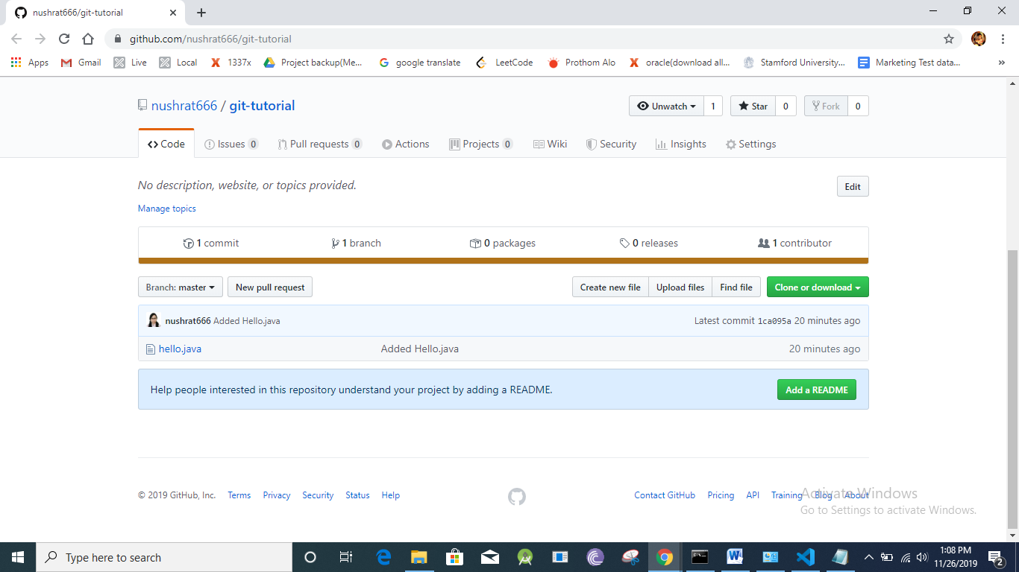

*again open hello.java file and write code  
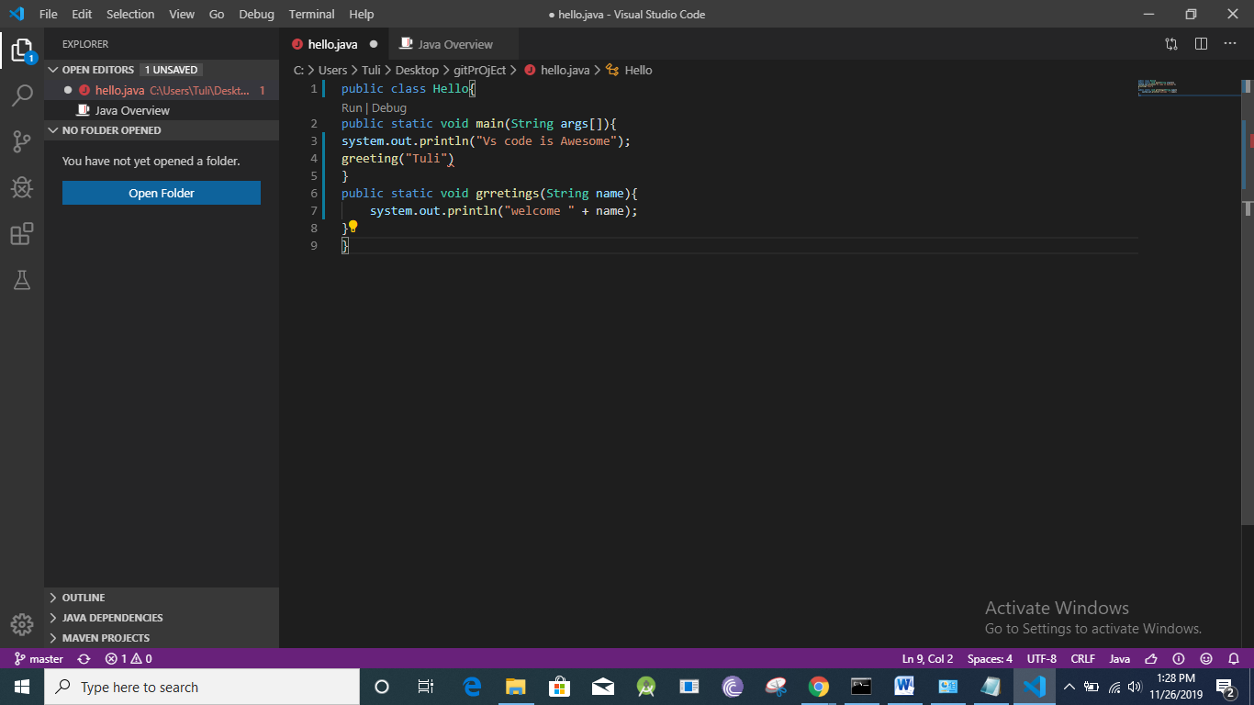  
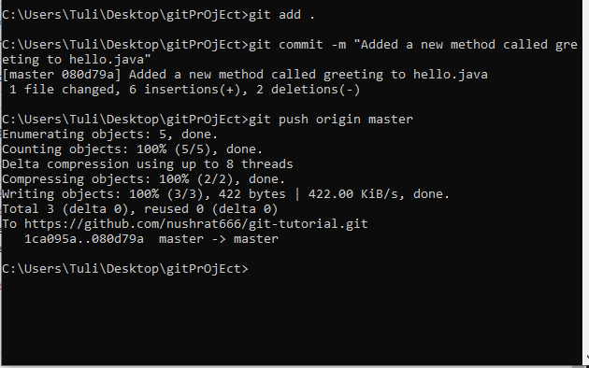

*after refresh this online page

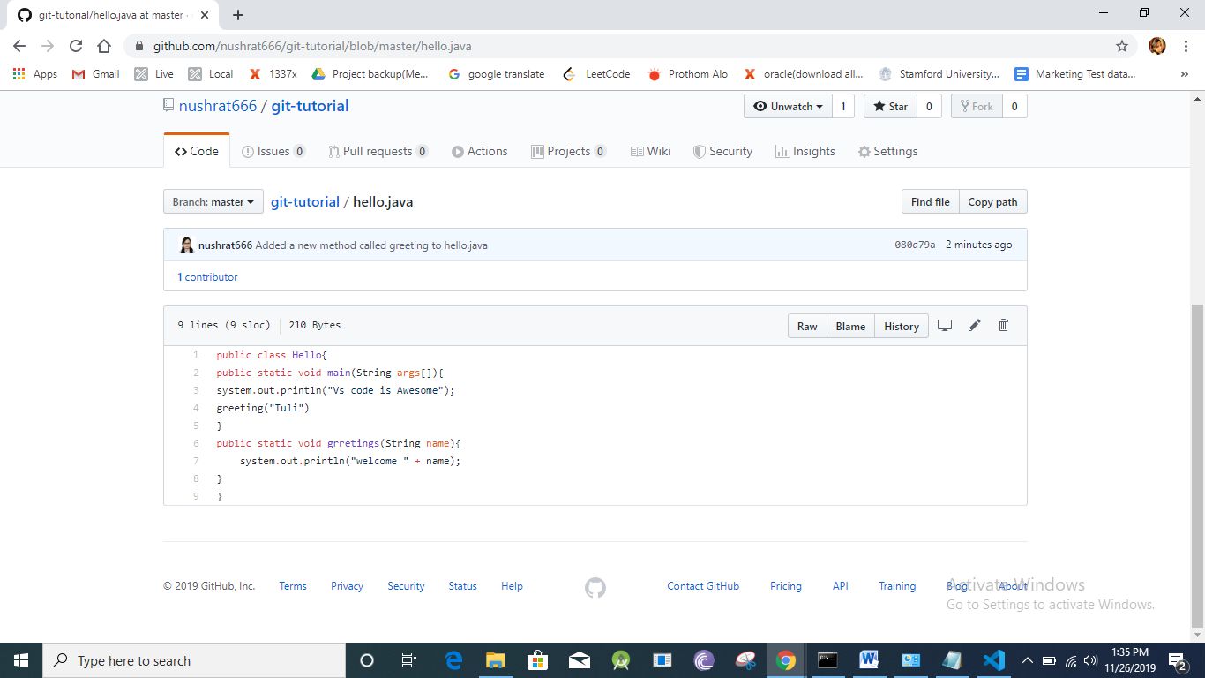

**Tutorial link: GitHub introduction For Beginners (Tutorial 4)**

<https://www.youtube.com/watch?v=Mf2rhvV667I&list=PL_XxuZqN0xVDDw5eyzuRDXBzgdnW7UpDF&index=4>

*master branch hocche main branch.. master branch e main file ta thakbe  
*new feature add korle notun ekta branch nibo, karon oitai Jodi vul thake tahole master branch er software crash khabe

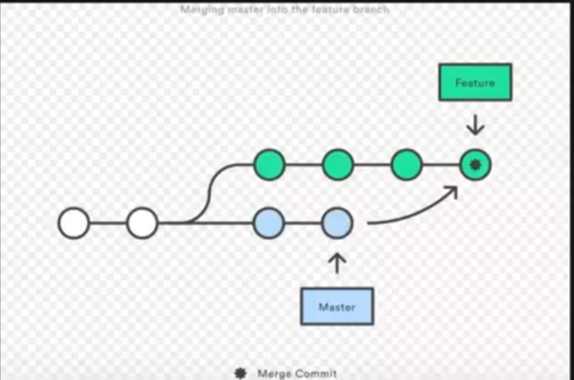

*kon branche e achi eta dekhar jonno

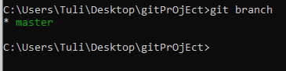  
  
*branch create korbo

  
*branch je create hoyeche eta check korar jonno  
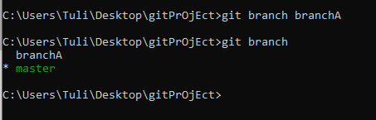  
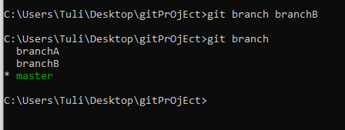

*master theke branch Ate gye kichu code change korte chai

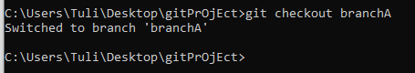  
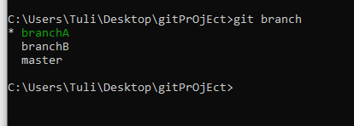

*kichu change korbo visual studio te

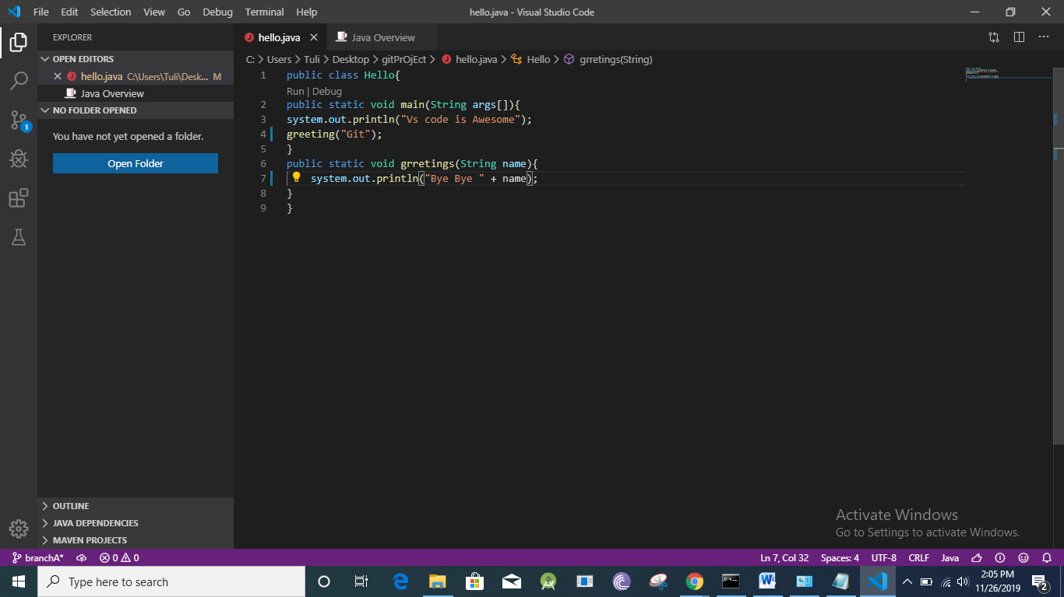

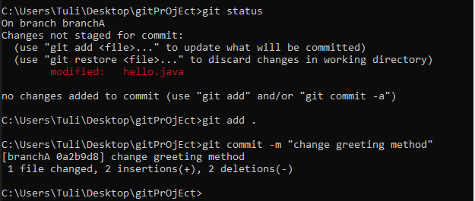

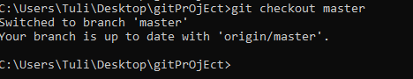

*visual studio era ager je code oitai abar dekhte parbo  
editing part ta r dekha jabe na

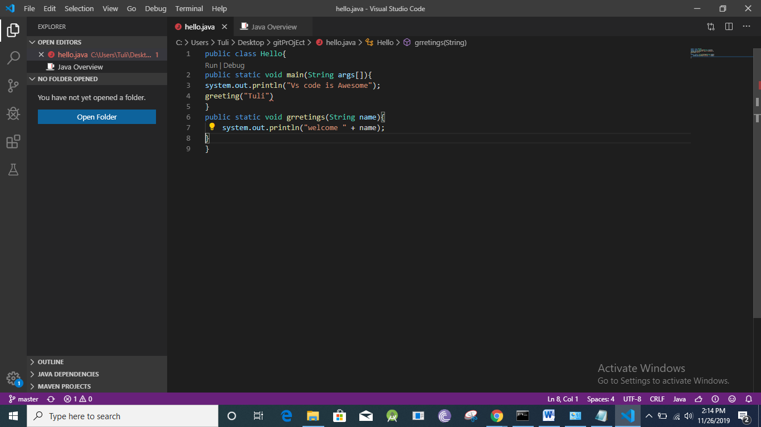  
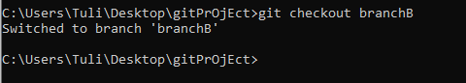

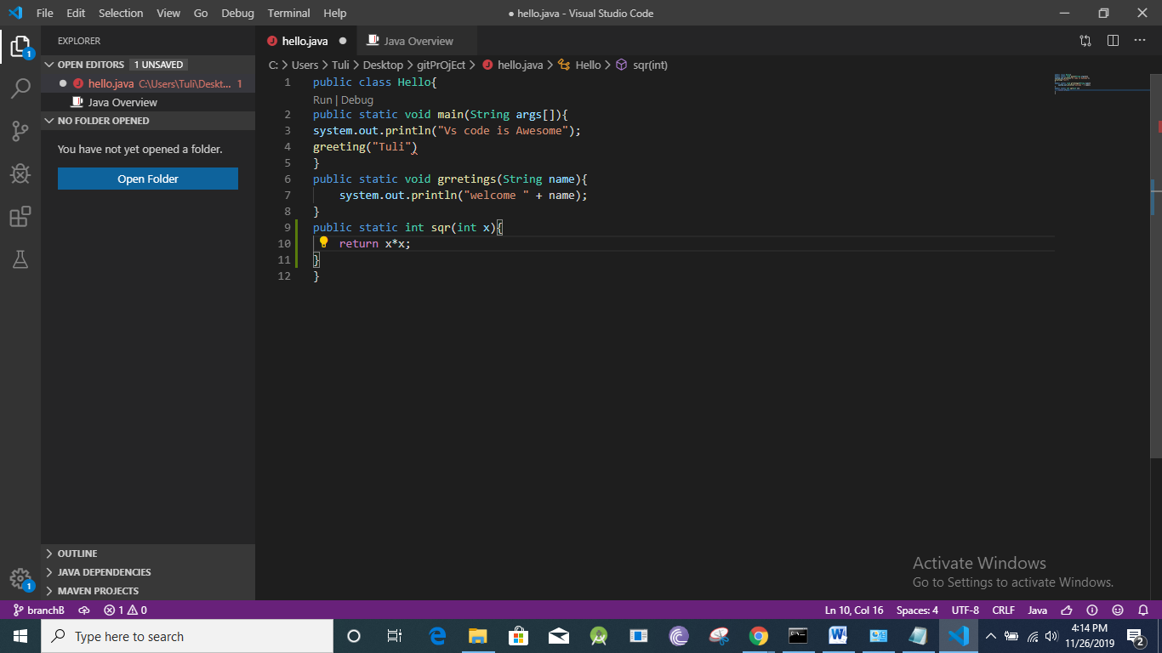

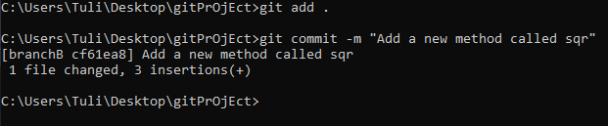  
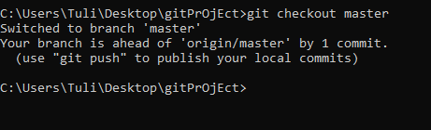

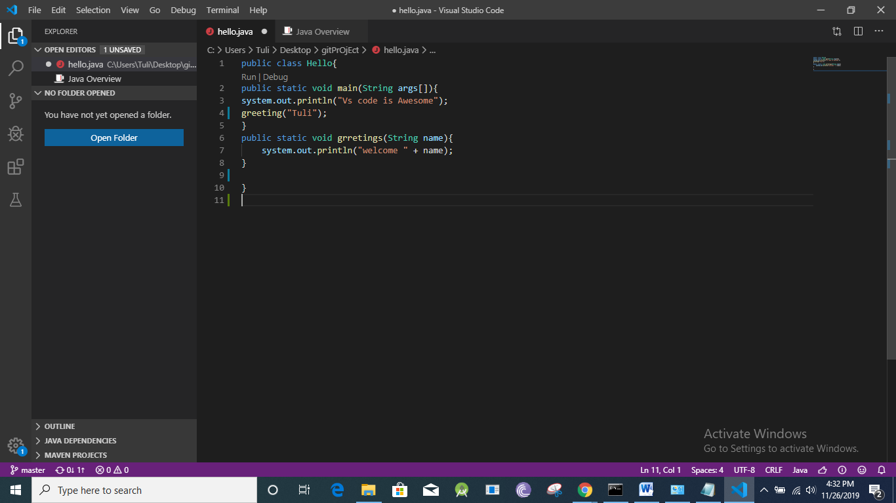

**Tutorial link: GitHub introduction For Beginners (Tutorial 5)**

<https://www.youtube.com/watch?v=sLDQLeXYaFg&list=PL_XxuZqN0xVDDw5eyzuRDXBzgdnW7UpDF&index=5>

merge: eta muloto kaj kore branch niye

code Jodi sothik hoy taile amra chabo segulo master branch er sathe add korte  
setai korbo merge er maddhome

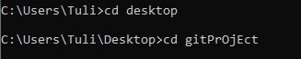

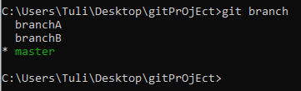



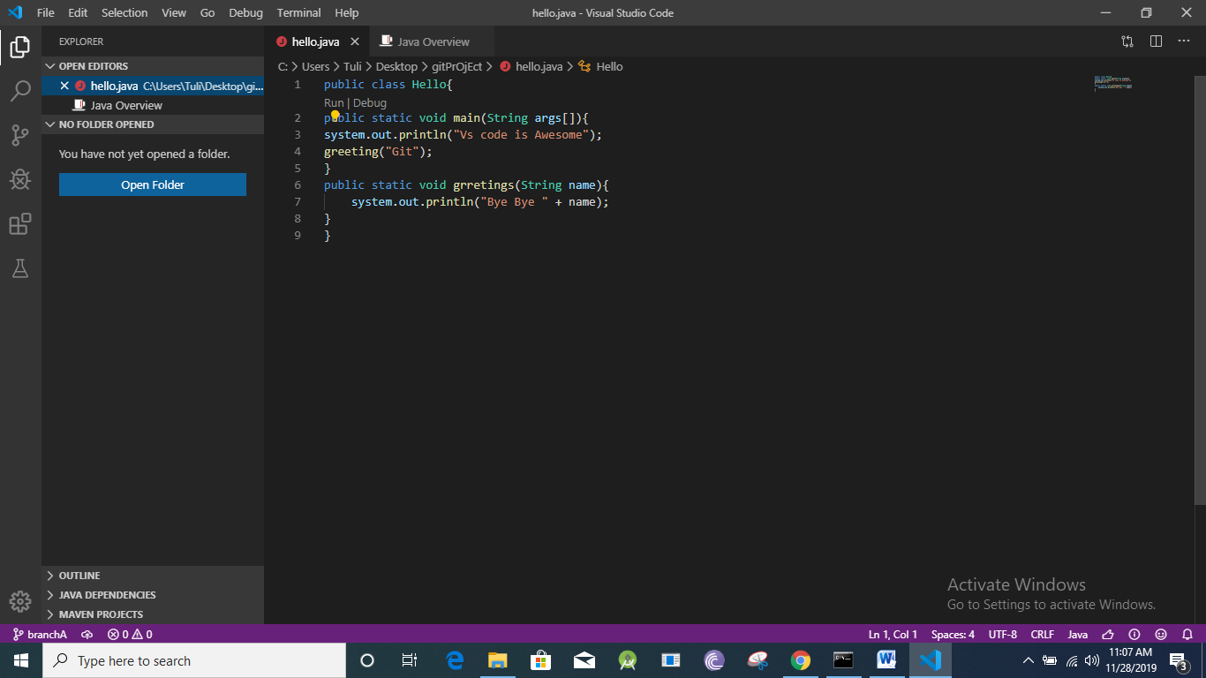

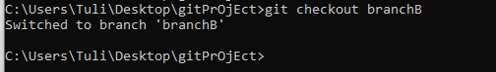

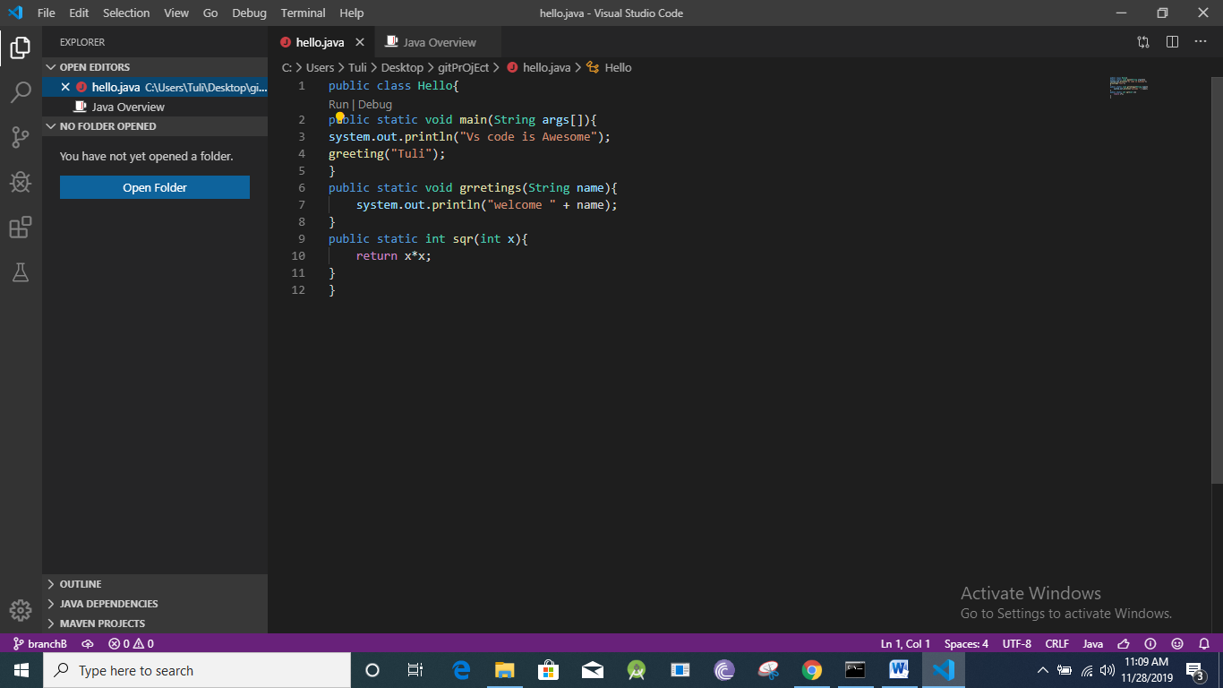

*b branch ta k master branch e merge korbo

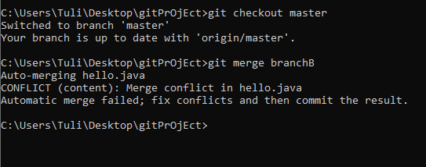

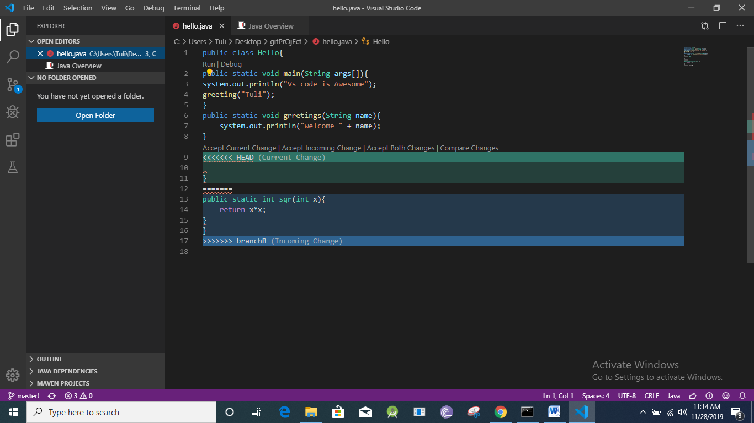  
merge conflict:

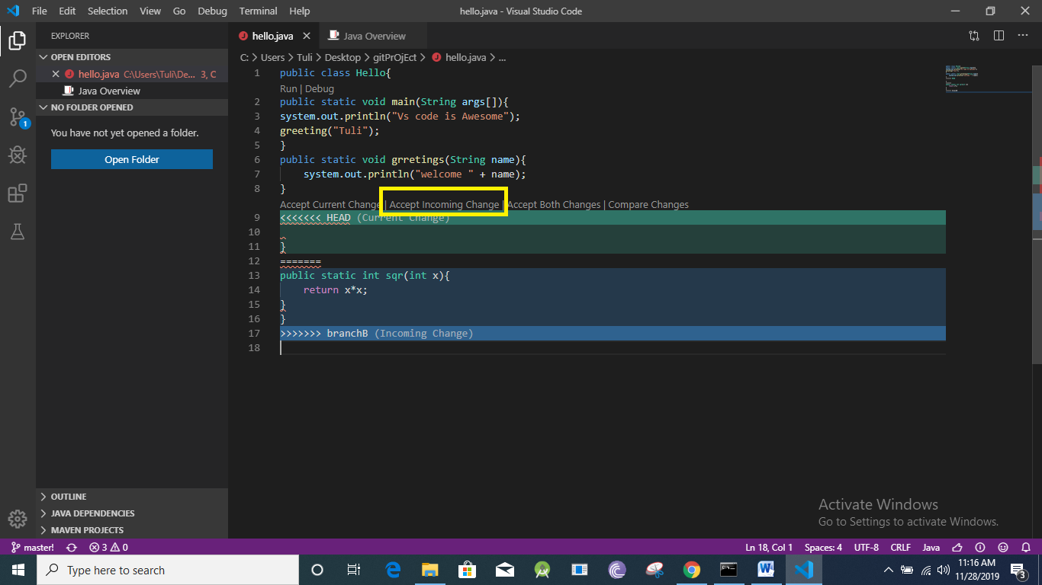

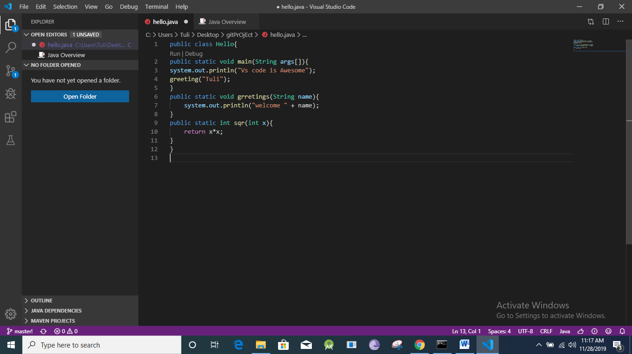

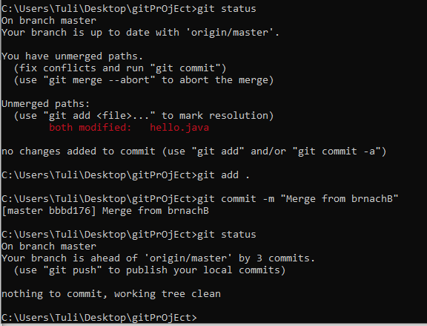

*ami xtra duita kaj korechi  
git add .  
git commit -m "create merge"

Ekhon abar merge korbo branchA k:

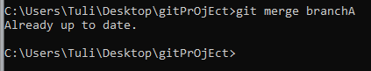

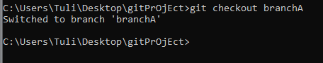

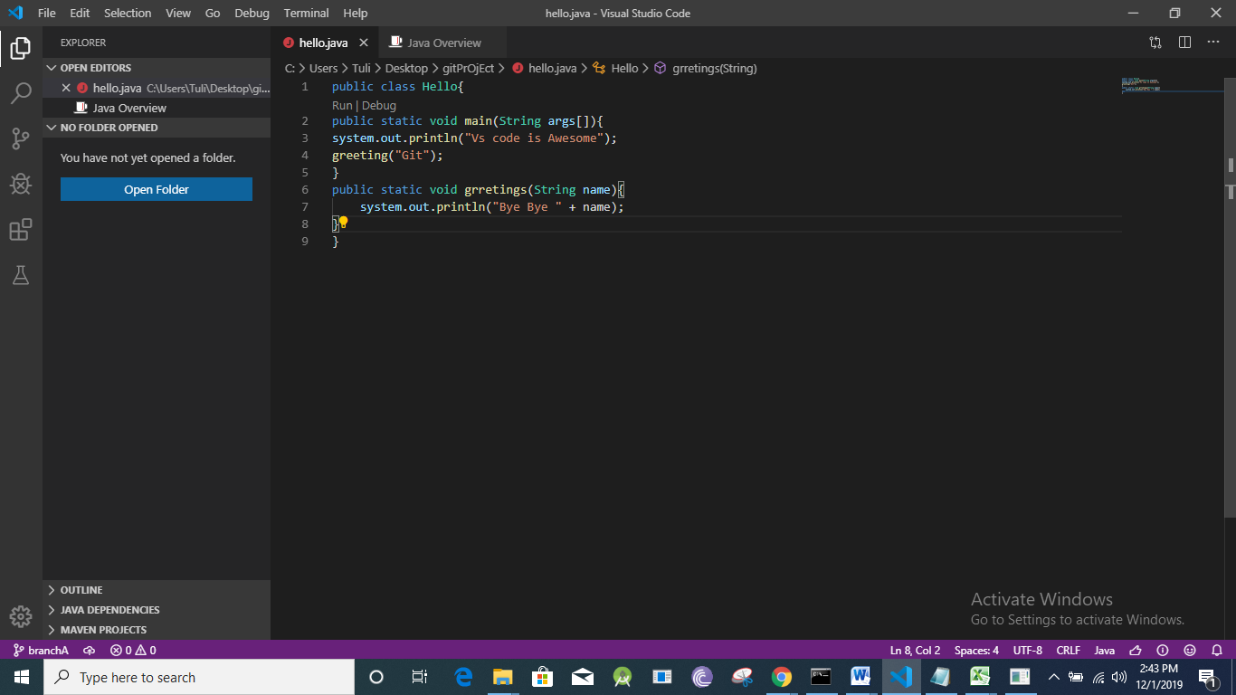

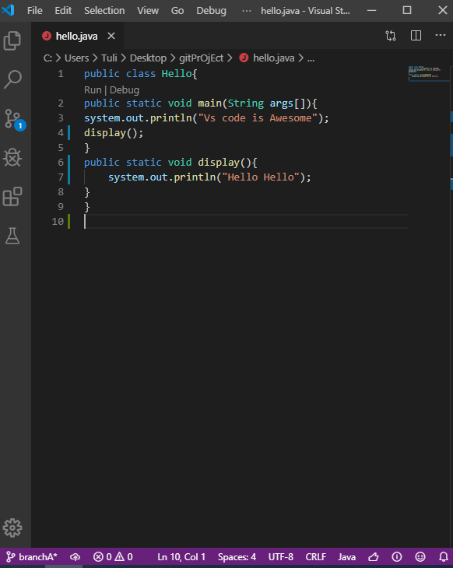

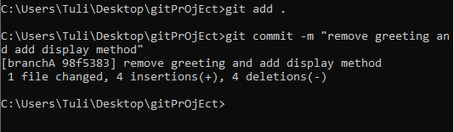

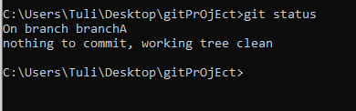

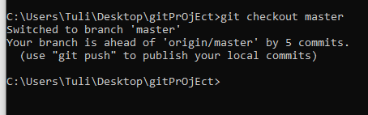

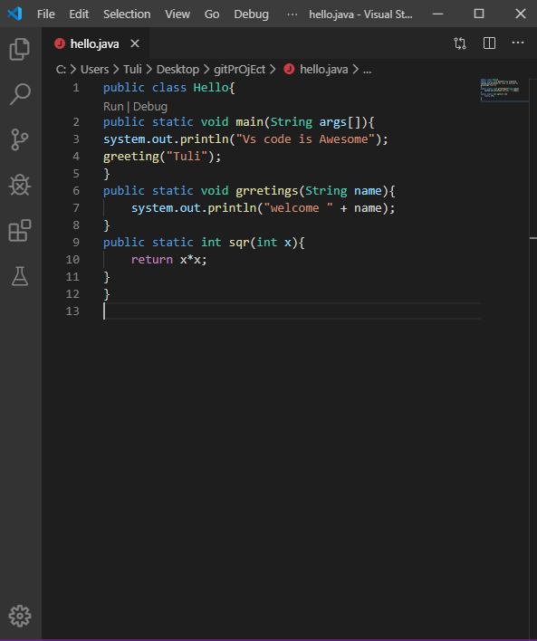

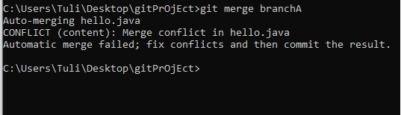

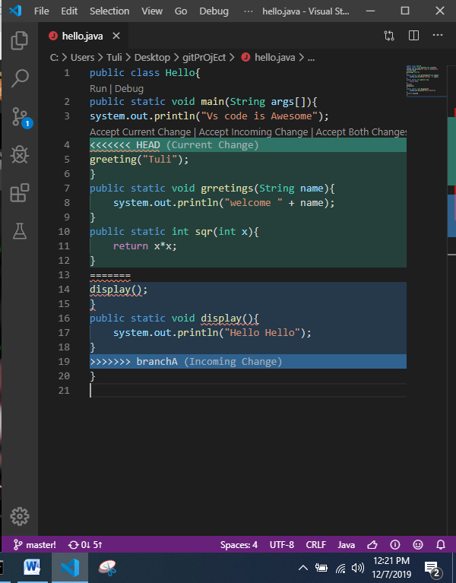

* Vs code e accept both change er pashe compare change ache, otai click korbo

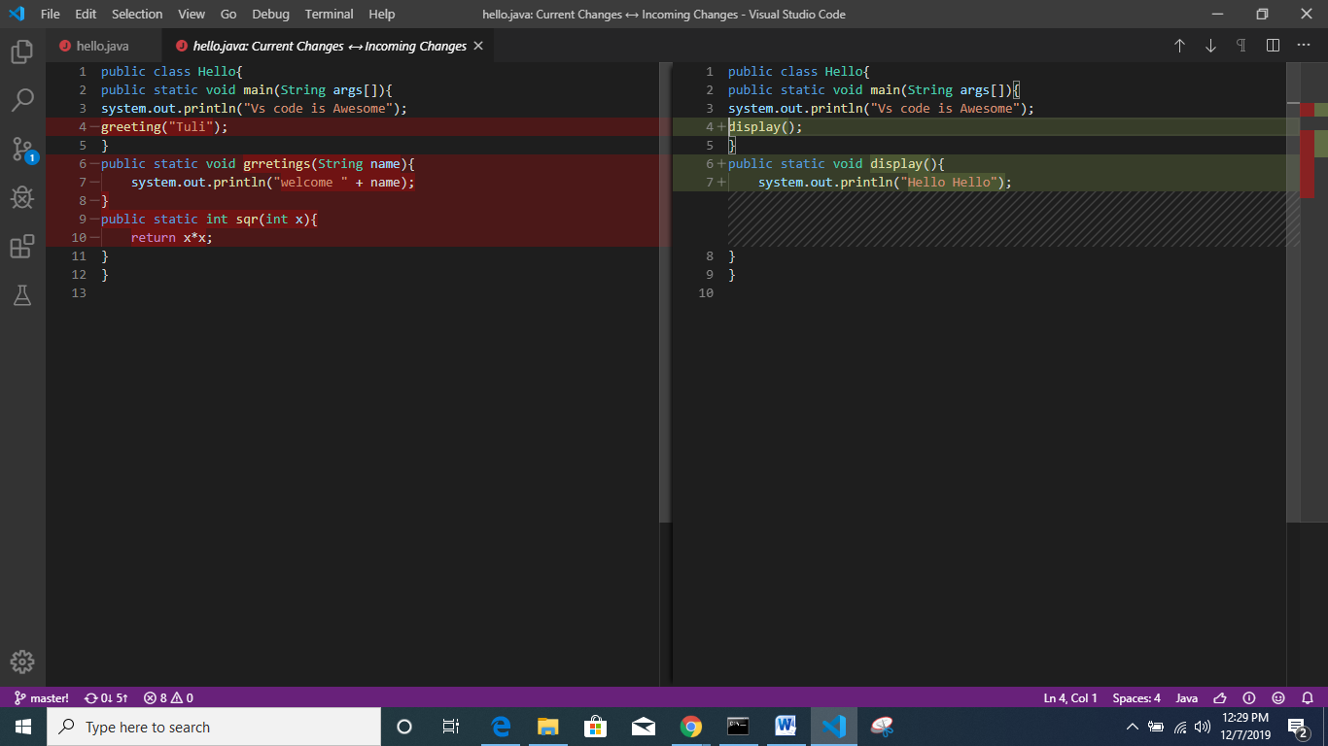

* >>>>>> egulo kete diye code ta nijei sajiye nilo

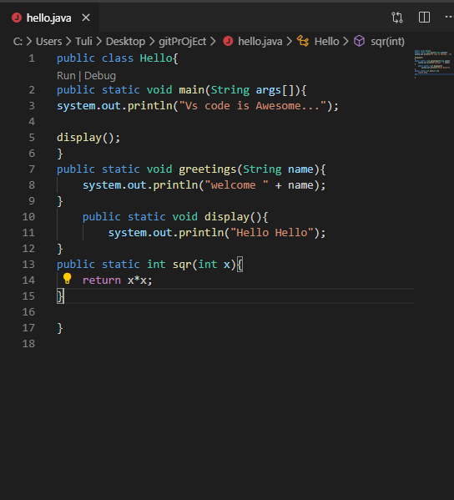

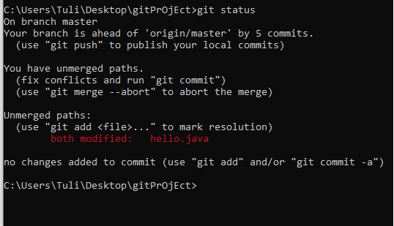

* Change ta k ekhon track kora lagbe

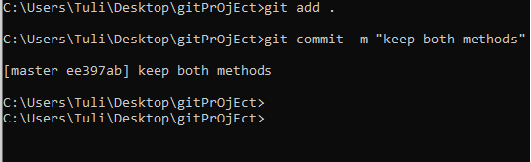

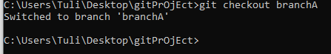

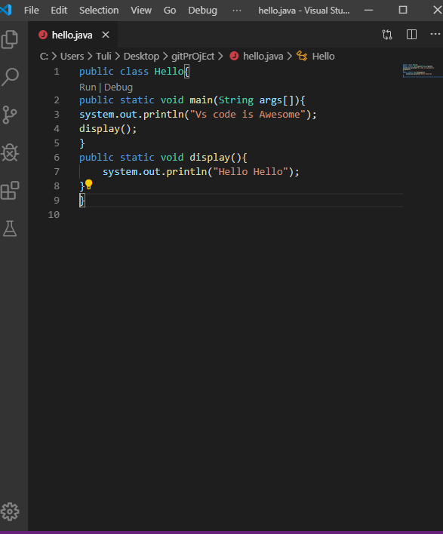

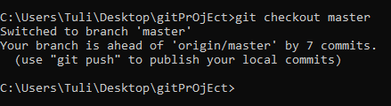

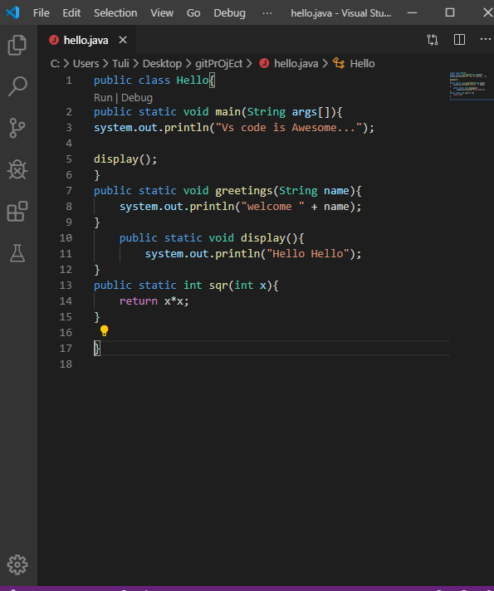

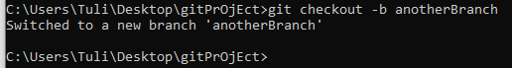

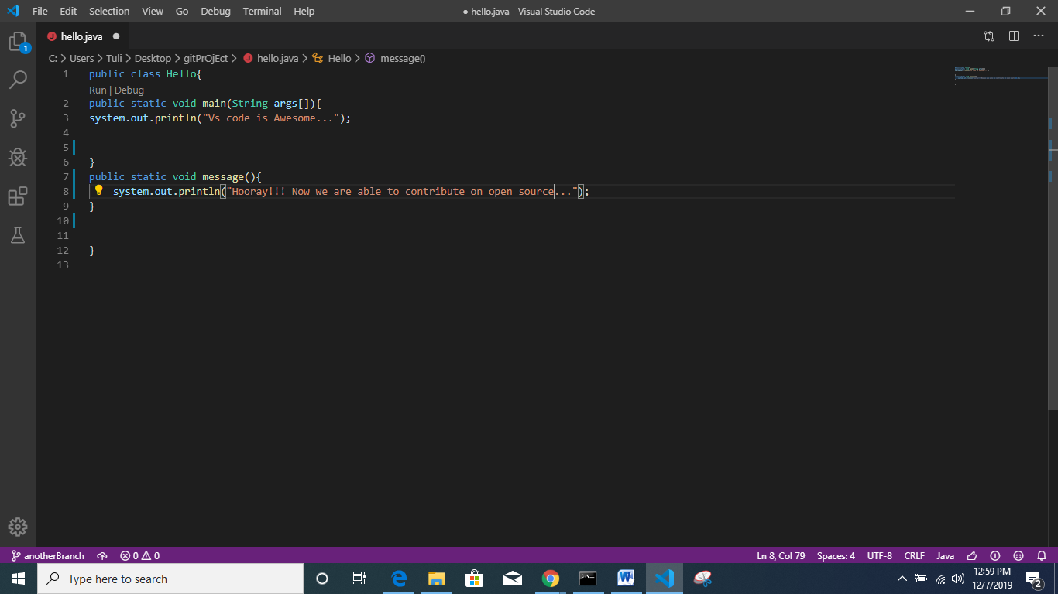

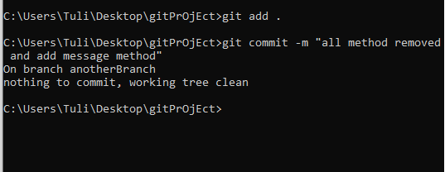

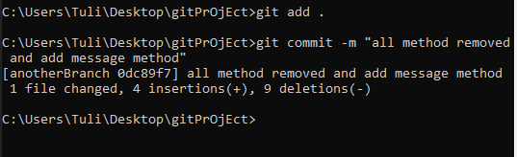

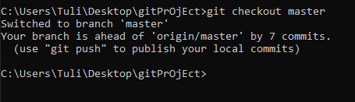

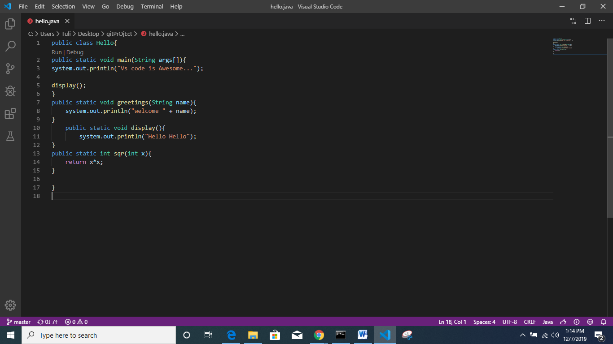  
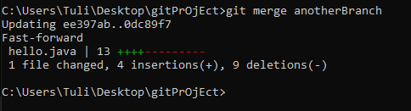  
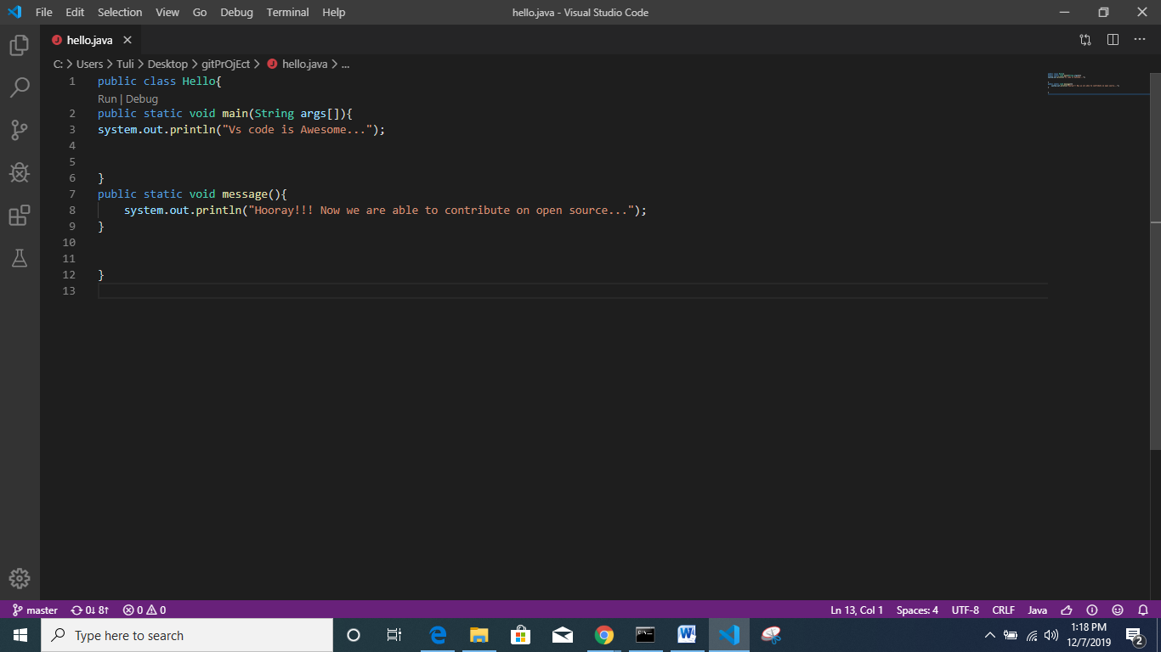  
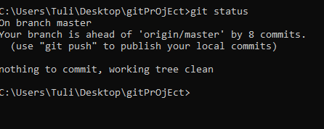  
  
*manually edit korle commit kora lagbe

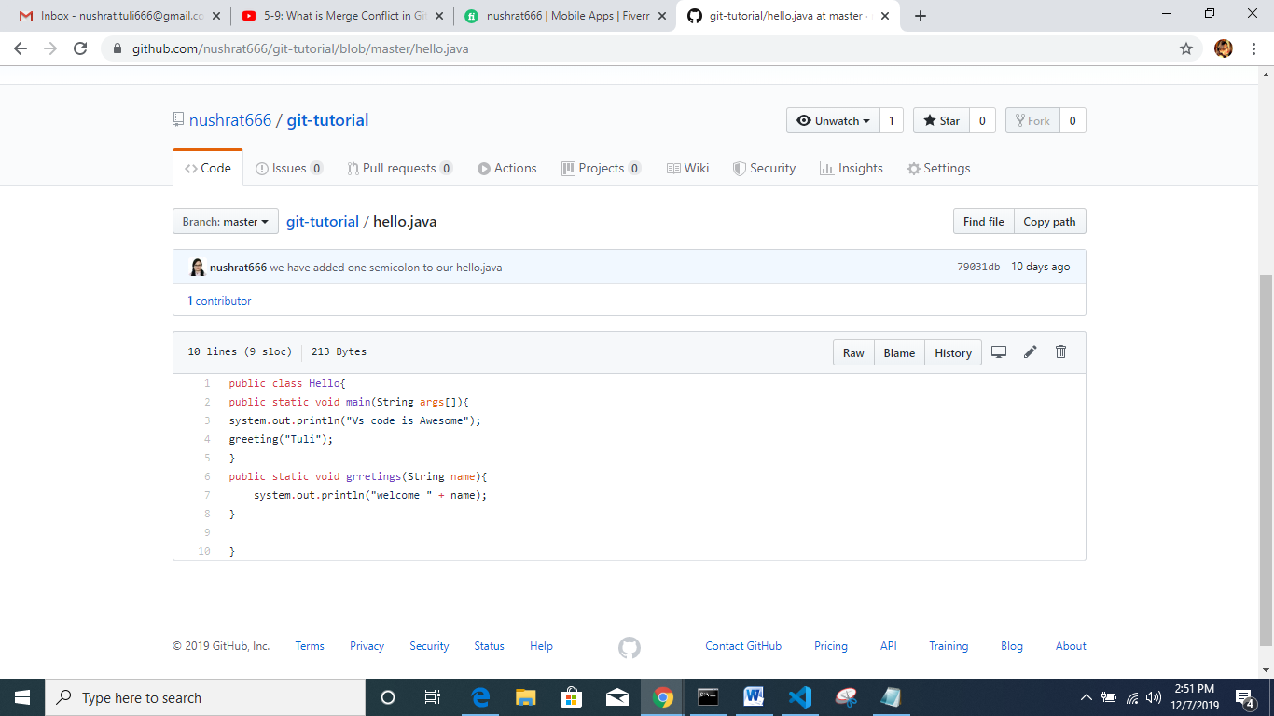  
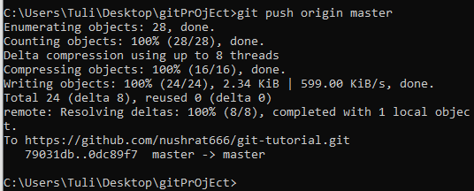

After refresh github page  
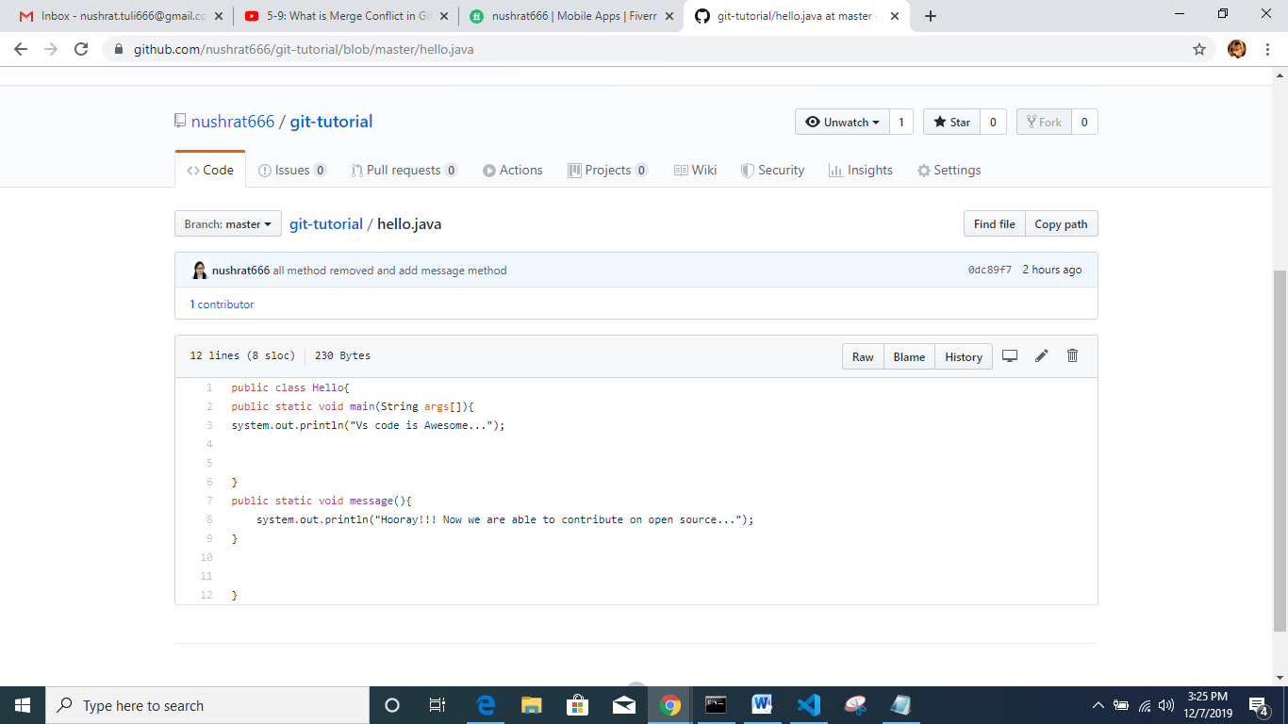

**Tutorial link: GitHub introduction For Beginners (Tutorial 6)**

<https://www.youtube.com/watch?v=fGEKHpSHCHY&list=PL_XxuZqN0xVDDw5eyzuRDXBzgdnW7UpDF&index=6>

*real open source niye kaj korbo

*fork git er kono ongso na, eta git hub er ongso

*fork mane onner jekono project and er vetor kar source code apnar profile e add korben

*add kore clone korte parbo and jekono kichu modify korte parbo

*modify korar por push korbo

*push korar por Jodi mone hoy ei poriborton ta ami chai tahole pull request pathabo

*project er author Jodi mone kore amr source code thik, tahole se eta k merge korbe

<https://github.com/jubelAhmed/c-project>

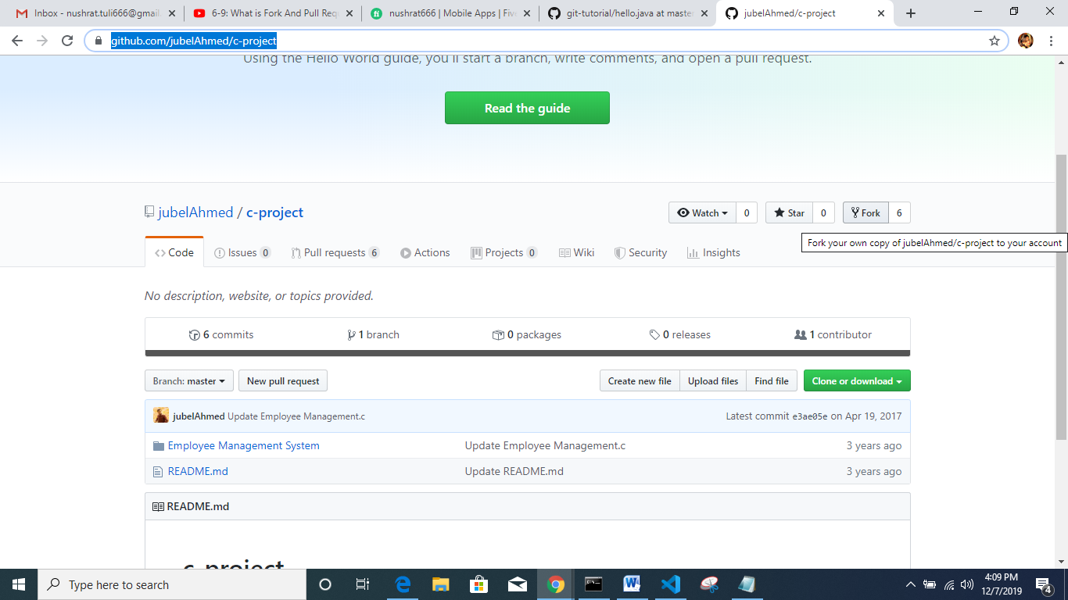

* Fork er upor click korbo

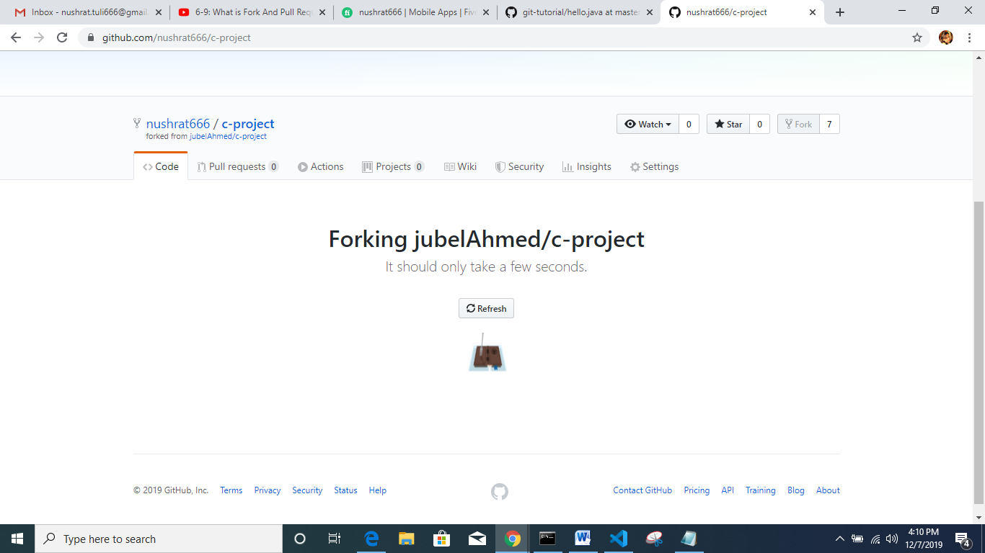

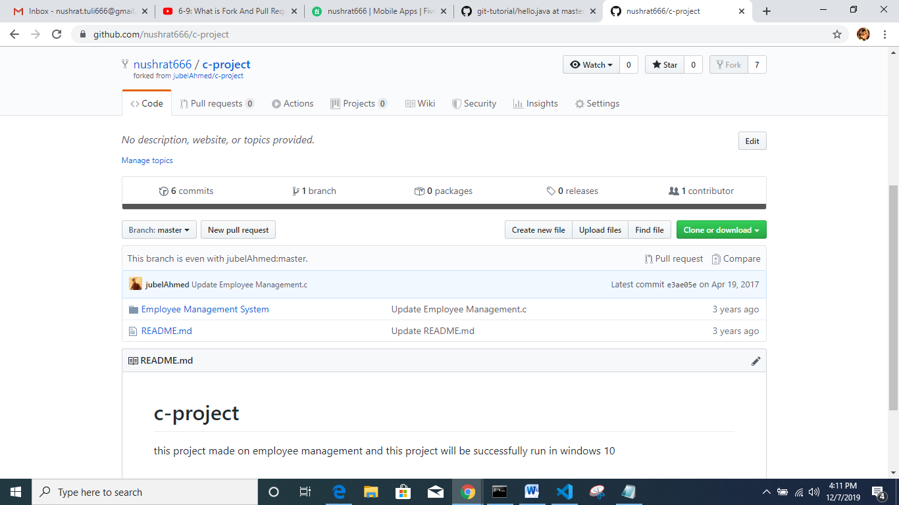

* Your profile e jabo

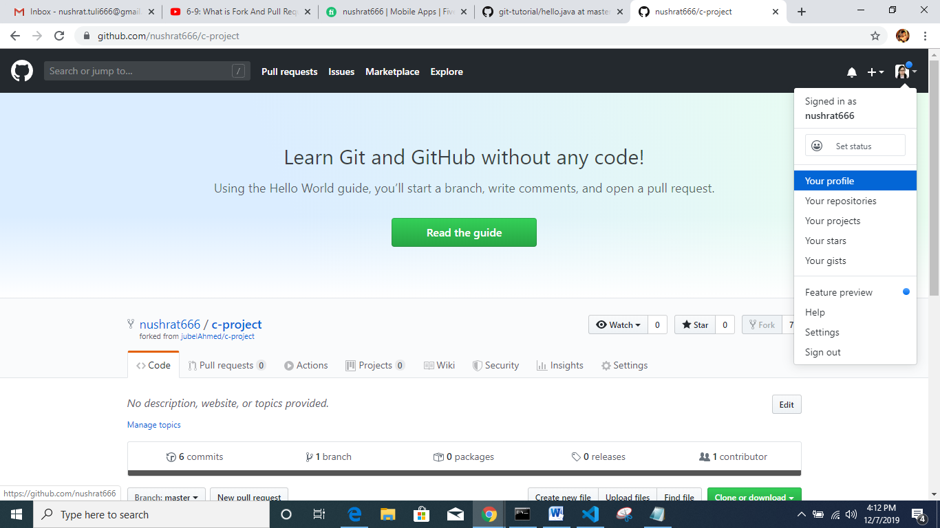

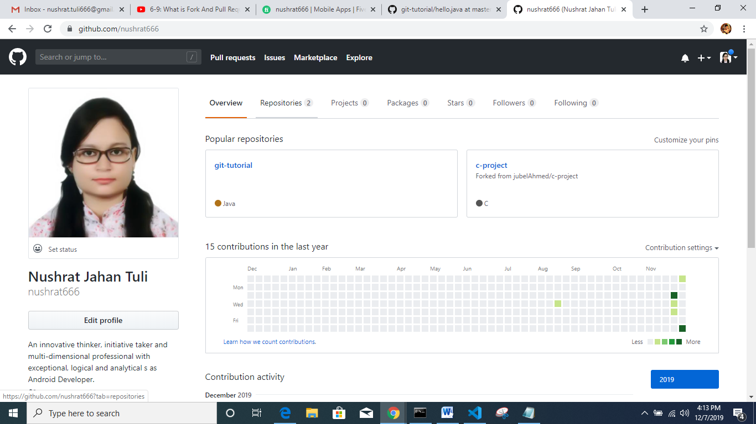

*repository te jabo

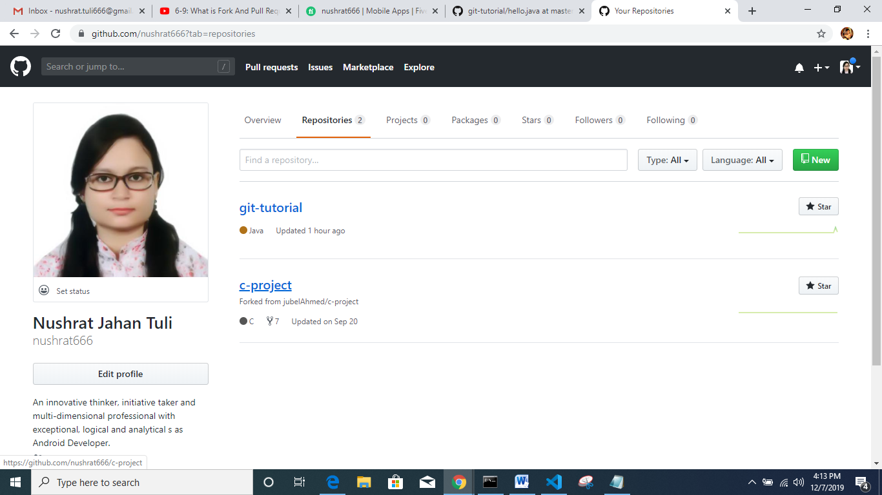

*dekhbo c-project ta amr repository te show korche

*ekhon c-project e click kore jabo

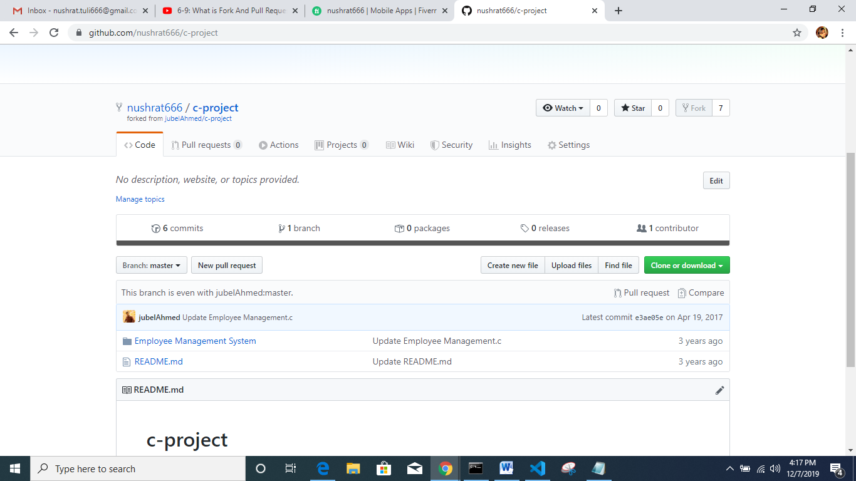

* Clone kora rakhbe

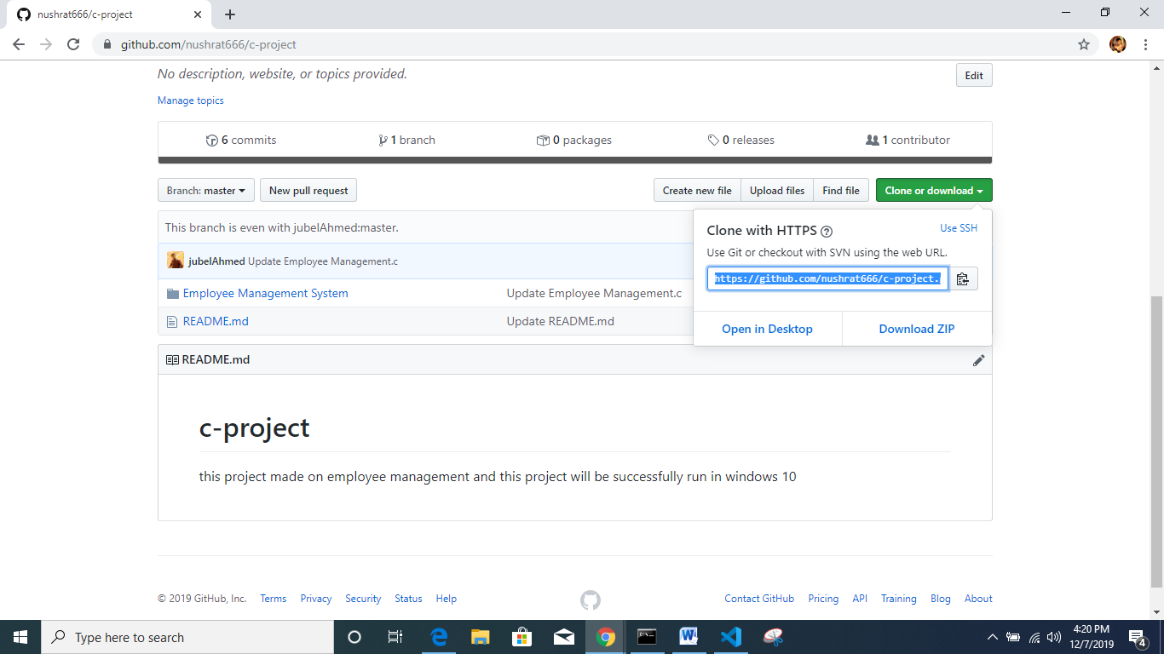

*link ta copy kore nibo

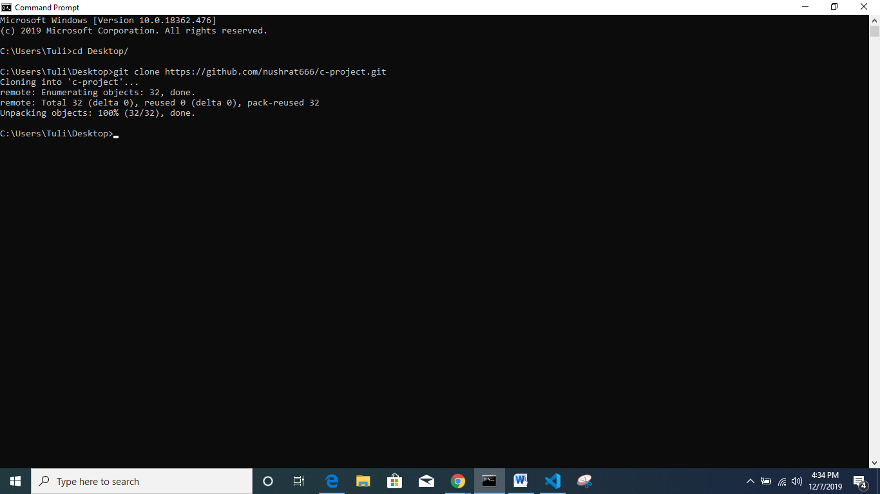  
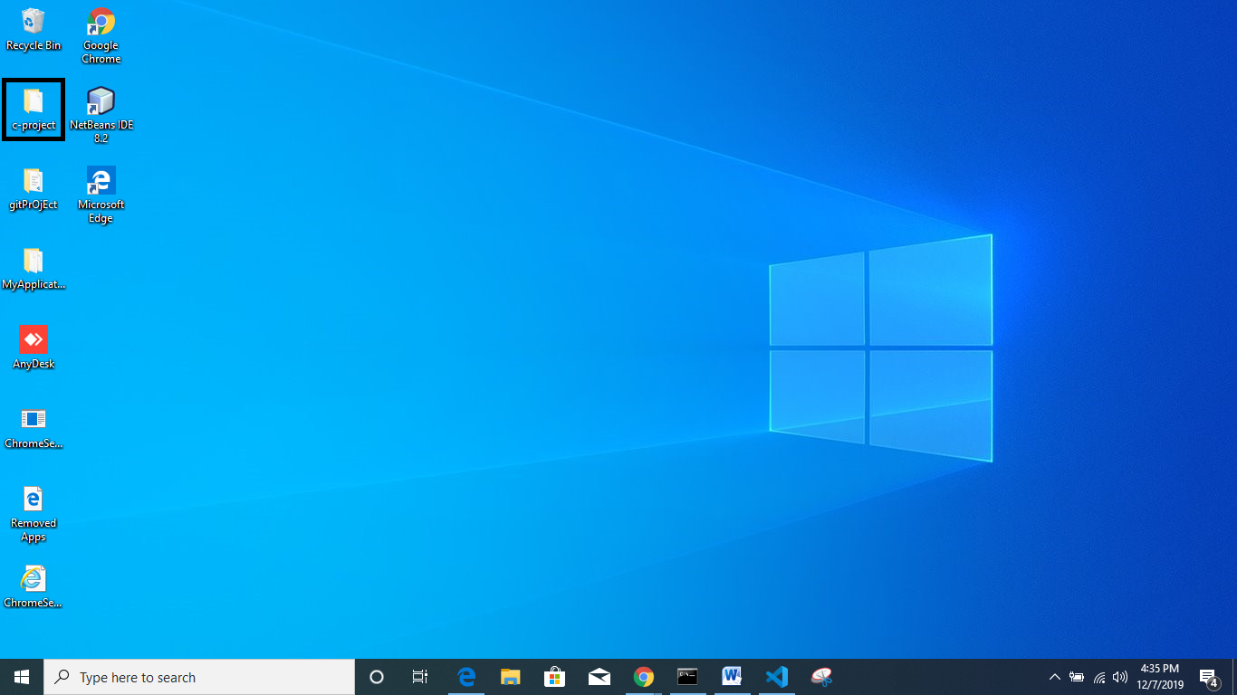

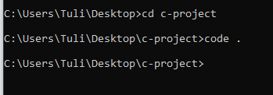

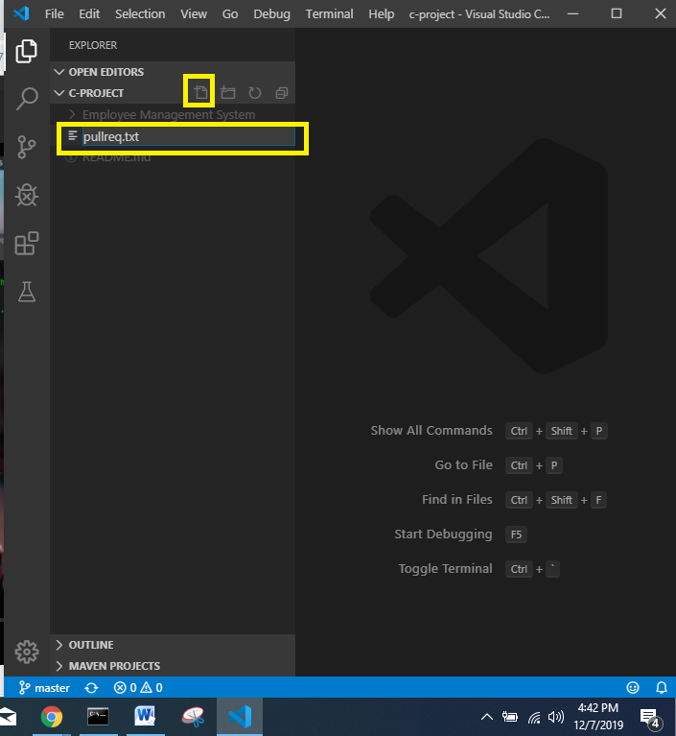

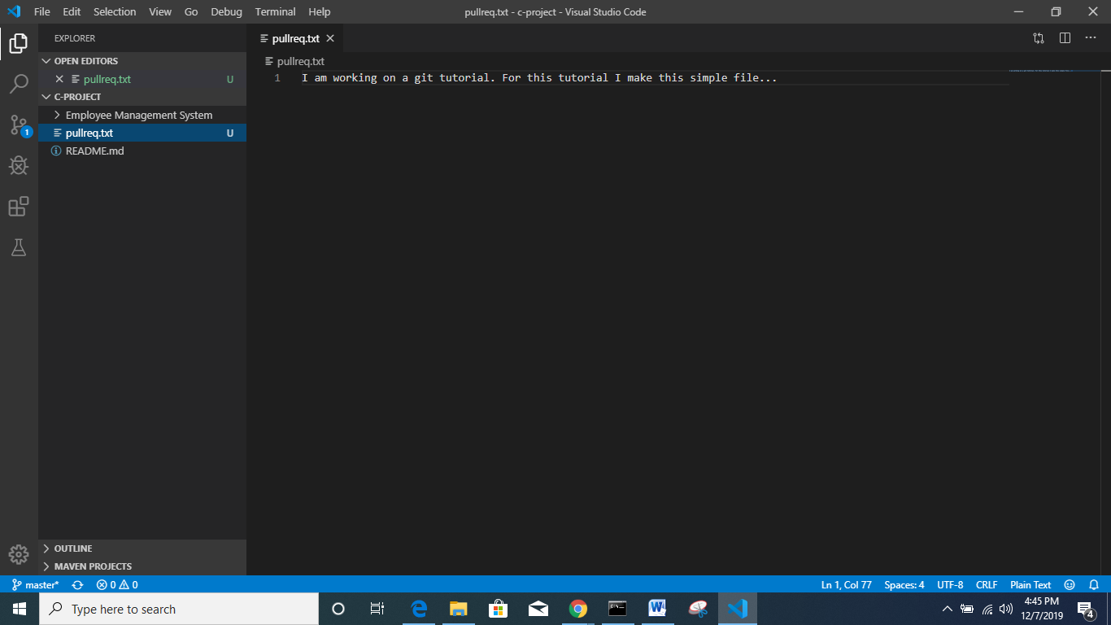

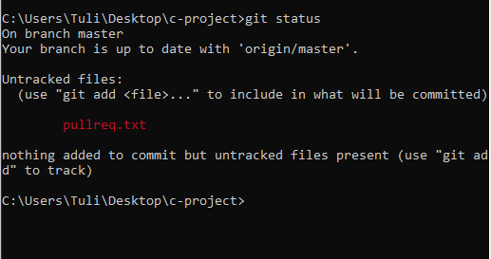

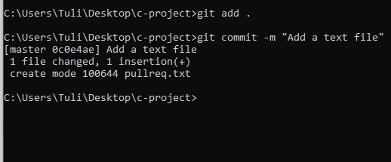

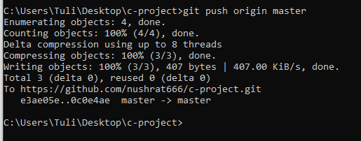

Reload git hub page

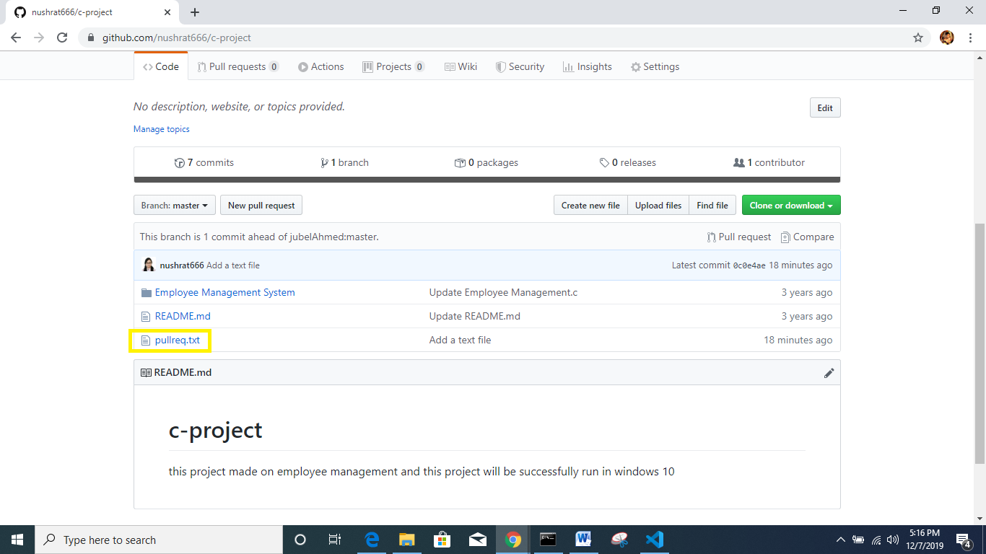

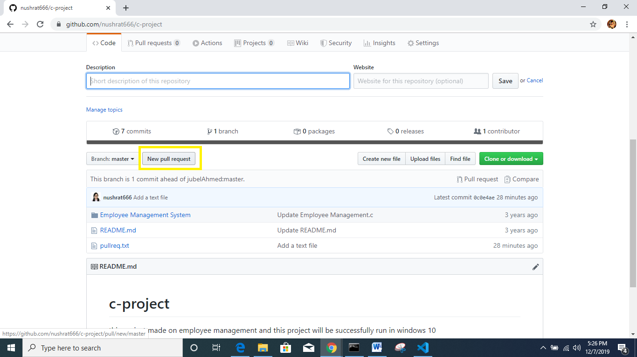

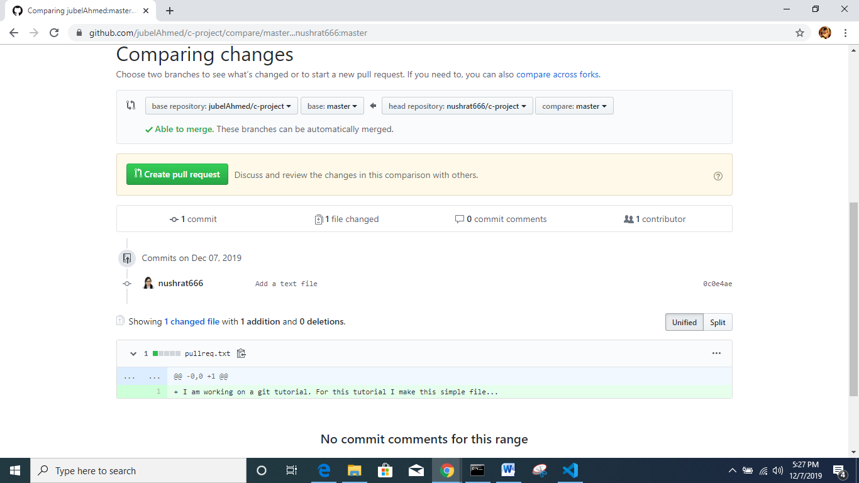

Create pull request e click korbo

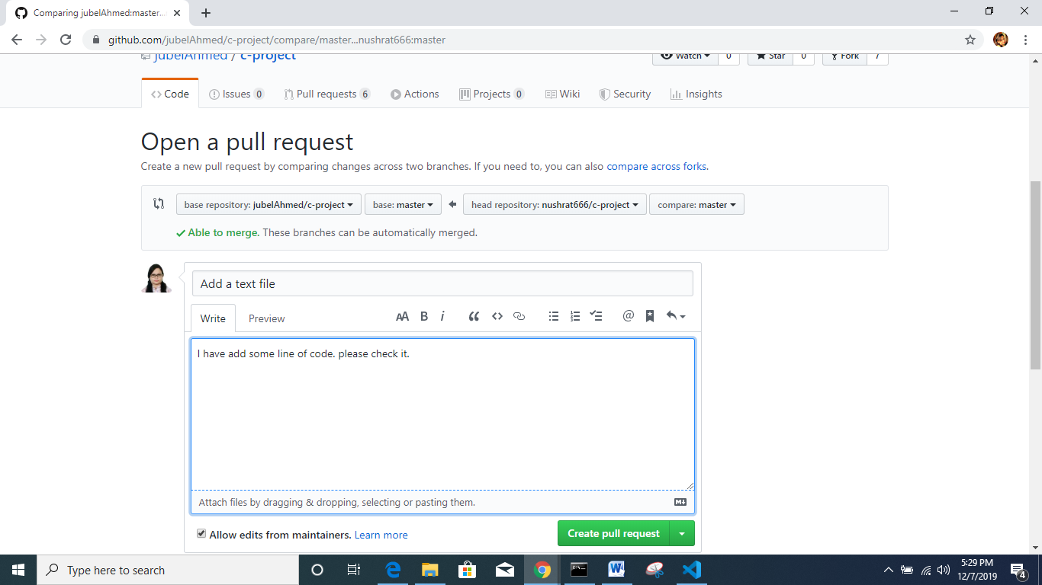

* Create pull request chapbo

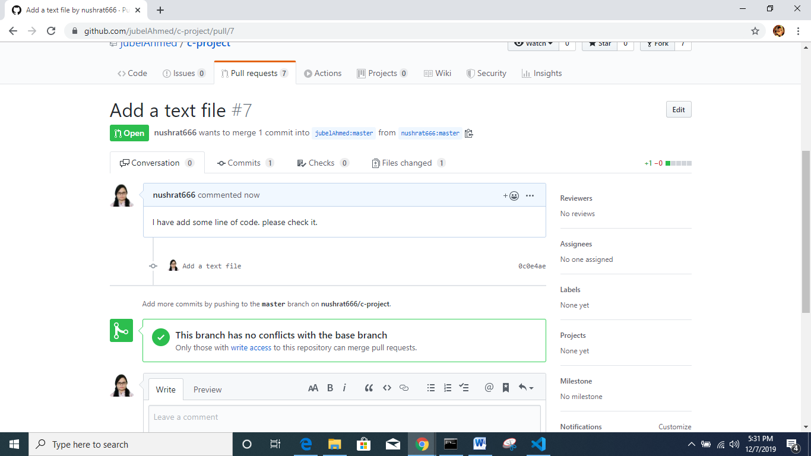

Git ignore:

*je file gulo amr git e rakhar proyojon nei, segulo git ignore bebohar kore save rakhte parbo

Jate txt file ta pore bujhte pare kon file ta ignore korleo cholbe

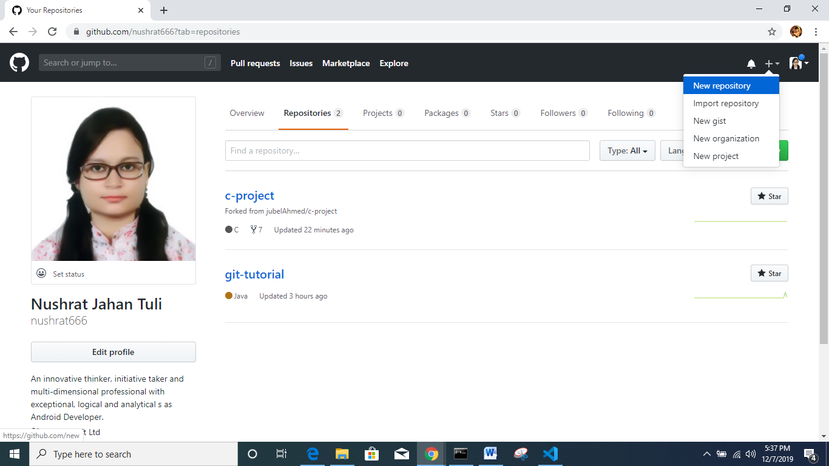

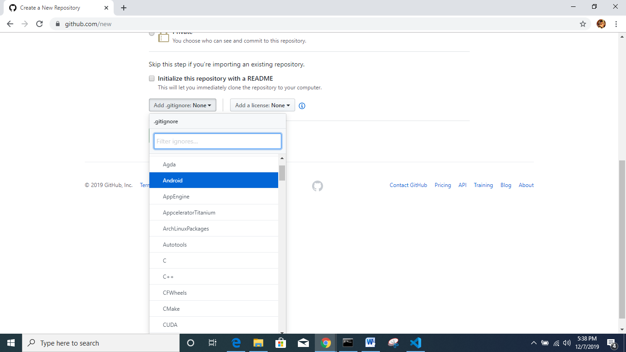

Ekhan theke android select kore dile Android project er unnecessary file gulo upload hobe na

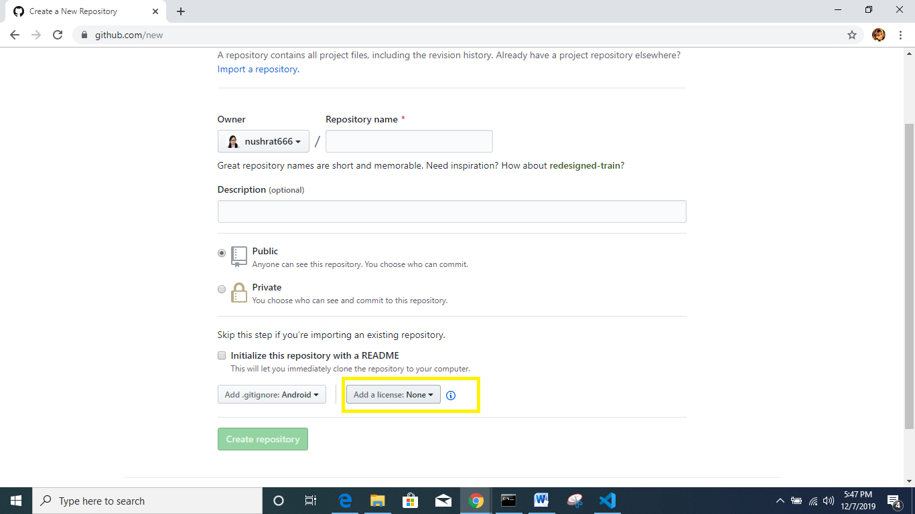

Project er licence thakle ekhane add kora jabe

But git ignore ta must add kora lagbe